Database Management Systems Lab

College logo | College name
 | Experiment Title: Introduction to SQL and installation of SQL Server / Oracle.
 | Laboratory: DBMS LAB
Experiment No: 1 | Department: | Semester:

Introduction to SQL
SQL (Structured Query Language) is a standard programming language used for managing and manipulating relational databases. It allows you to perform various operations such as:
- Querying data: Retrieving specific data by using the SELECT statement.
- Updating data: Modifying existing data with the UPDATE statement.
- Inserting data: Adding new data using the INSERT statement.
- Deleting data: Removing data with the DELETE statement.
- Creating and modifying database structures: Using CREATE, ALTER, and DROP statements for tables, indexes, and other database objects.
What kind of information do these Databases hold?
They can hold a variety of information or maybe anything that you could think of—ranging from catalogs of product, customer information, images metadata, text data, etc.
In order for the information to be easily accessible and understandable, you need database management systems or relational database management system. DBMS can be helpful in a variety of ways, like sorting information or linking databases to each other, provide reports about any updates in the database, and even manage administrative access to the database.

Some of the most popular SQL databases are:
- MySQL: It is the most popular open-source relational database management system. Just to name a few, MySQL is currently being used by Facebook, Youtube, and Twitter. Since it's open-source, it comes without any cost associated with it.

- Oracle Database: It is a multi-model DBMS developed by Oracle and is written in the C++ language. It is widely used for running online transaction processing like bank payment server websites. Though being costly, it is very reliable. To handle unstructured data, Oracle has also released an Oracle NoSQL database

- Ms SQL: An RDBMS developed by Microsoft. It supports both structured (SQL) and unstructured (NoSQL) data. Its primary function is to store and retrieve data based on the requests it receives from other software-like applications. It is fast and stable and works well with other Microsoft based products.

- Microsoft Azure: It is a cloud computing service created by Microsoft. Its primary functionalities are building, testing, deploying, and managing applications and services which are managed by Microsoft owned data centers. It provides software as a service (SaaS), platform as a service (PaaS) and infrastructure as a service (IaaS)(Source). It has support for various programming languages. It is considered to give a tough competition to Amazon Web Services (AWS) and Google Cloud Platform (GCP).

Installation of SQL Server

How to Download MySQL Server:

1.So go to Google.com or Microsoft edge.com or your favorite search engine and search for Download MYSQL Server.

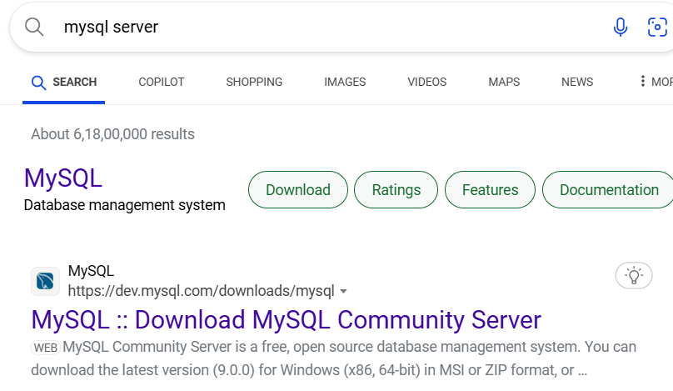
Figure 1-Search MySQL
2. Click on download to download the MySQL.

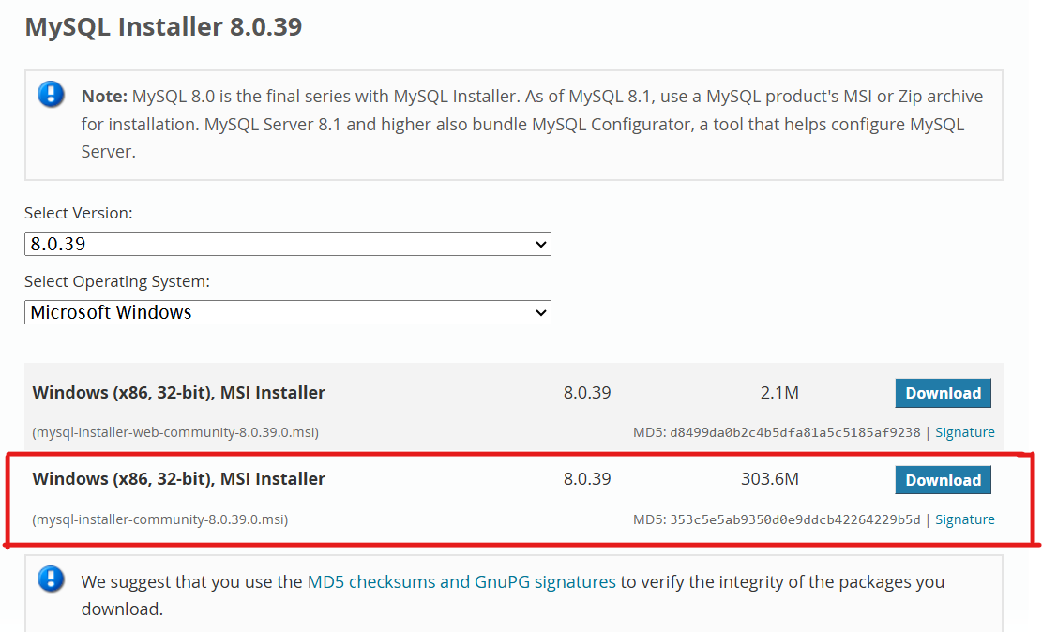
Figure 2-Download MySQL
3.Now after downloading, MySQL sever setup will open, which you have to select. According to your requirement and then click on next.

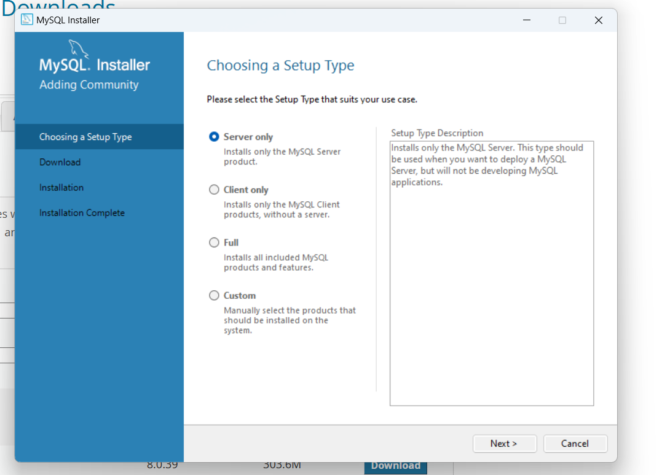
Figure 3-Choosing setup type
4. Now after choosing the setup, MySQL setup is ready to install by clicking on execute.
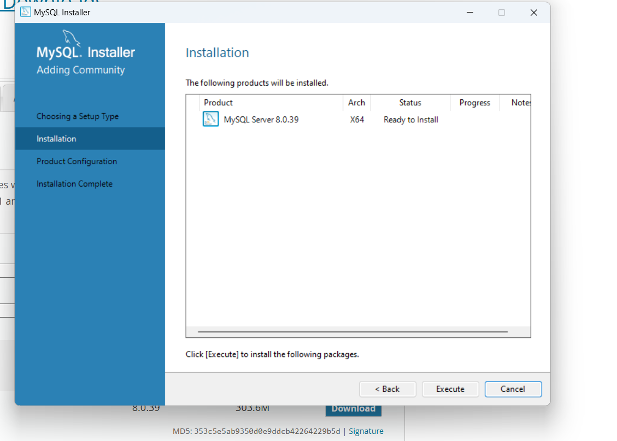
Figure 4- Installation of MySQL
5.After installation, now we have to setup server configuration after setting up the server configuration click on next to proceed.

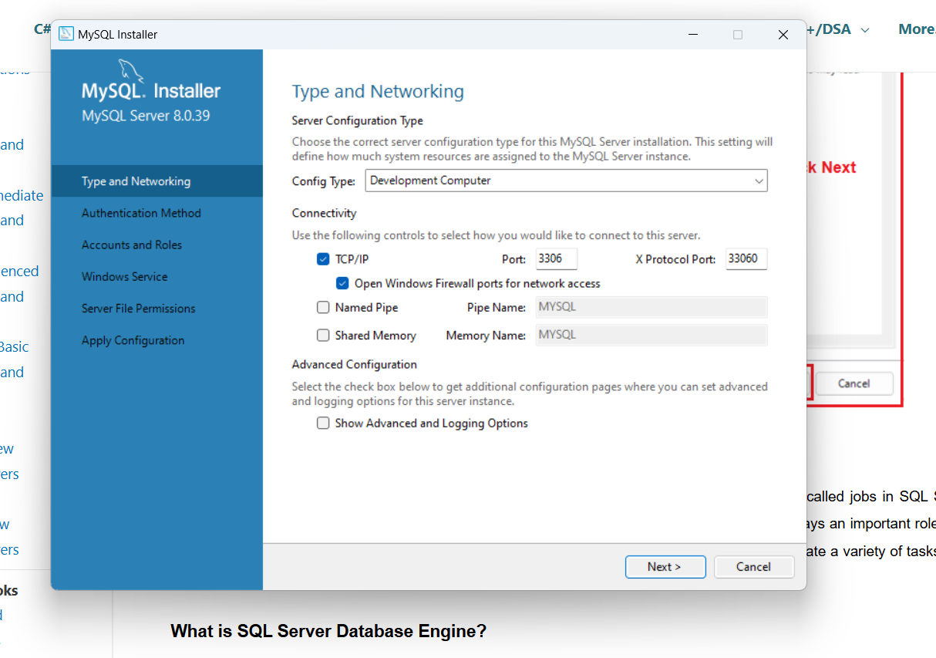
Figure 5-Server configuration
6. Now after server configuration, authentication method used in MySQL will be shown.

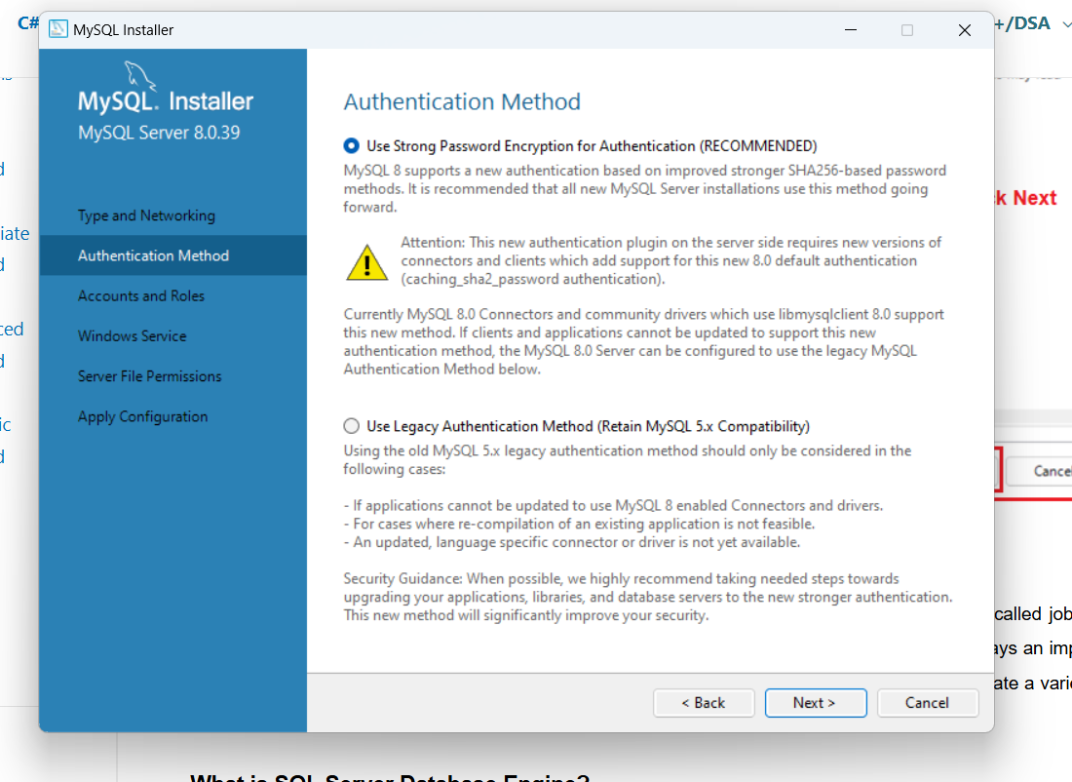
Figure 6-Authentication

7.Now we have setup a MySQL account password.

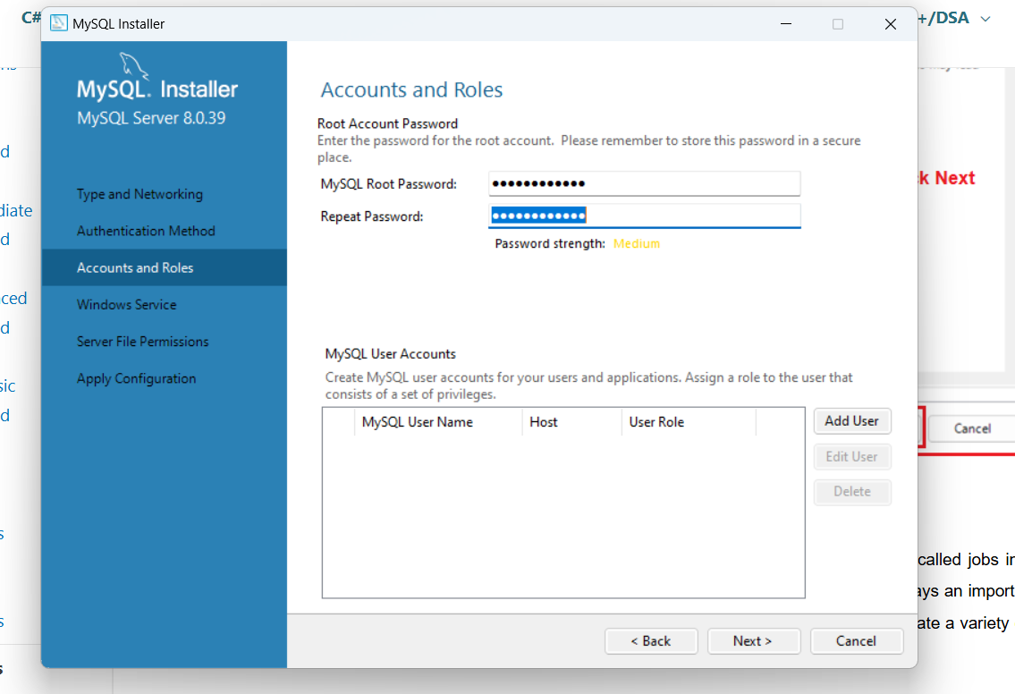
Figure 7-Password setup
8. After setup of account password, then setup window services.

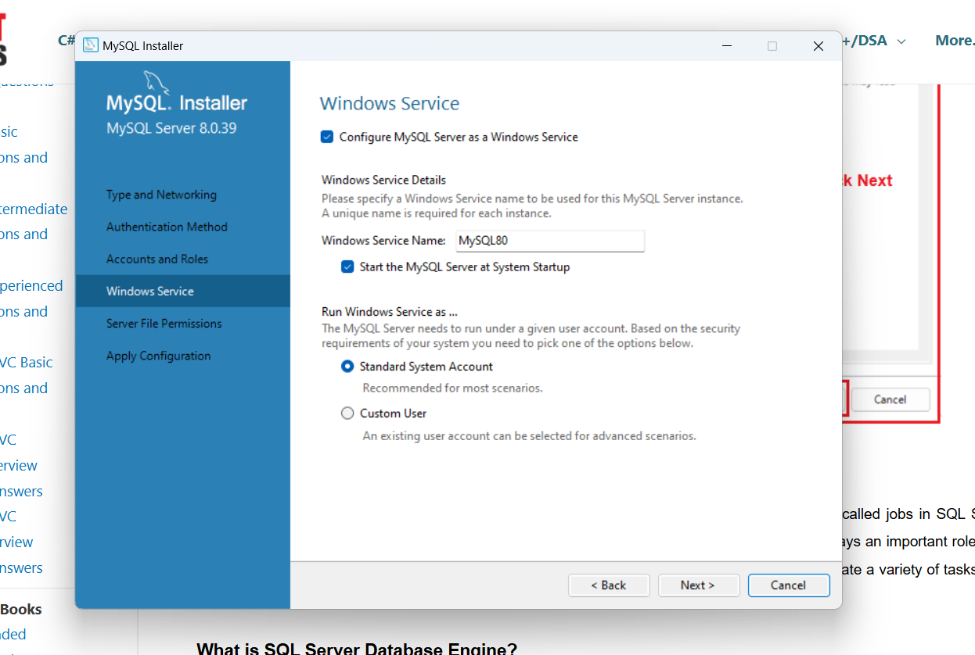
Figure 8-Window services
9.Now setup the server file permission.

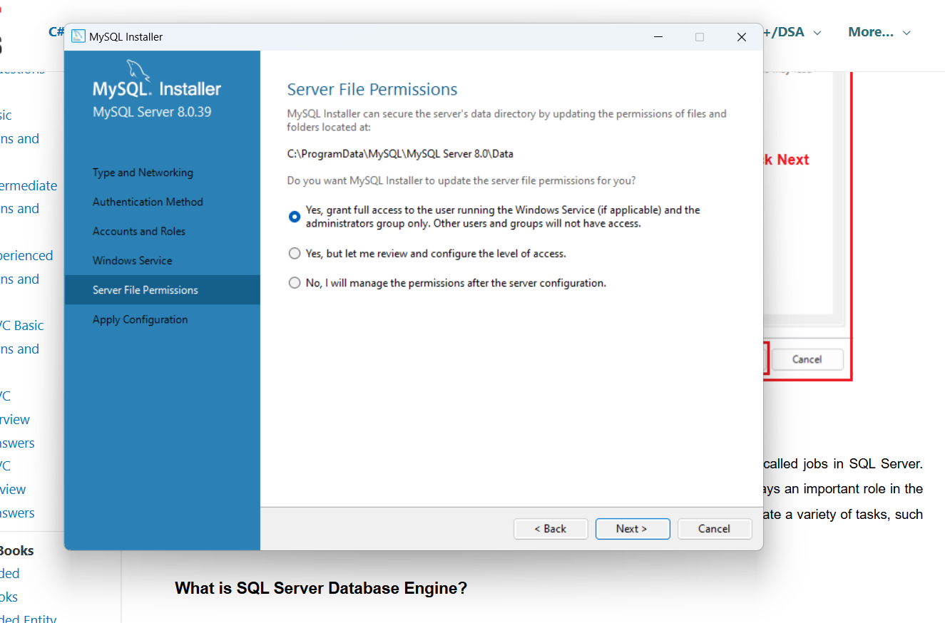
Figure 9-File permission
10. Now after performing above operation, now you have to apply the configuration by clicking on execute, then click on finish to setup MySQL.

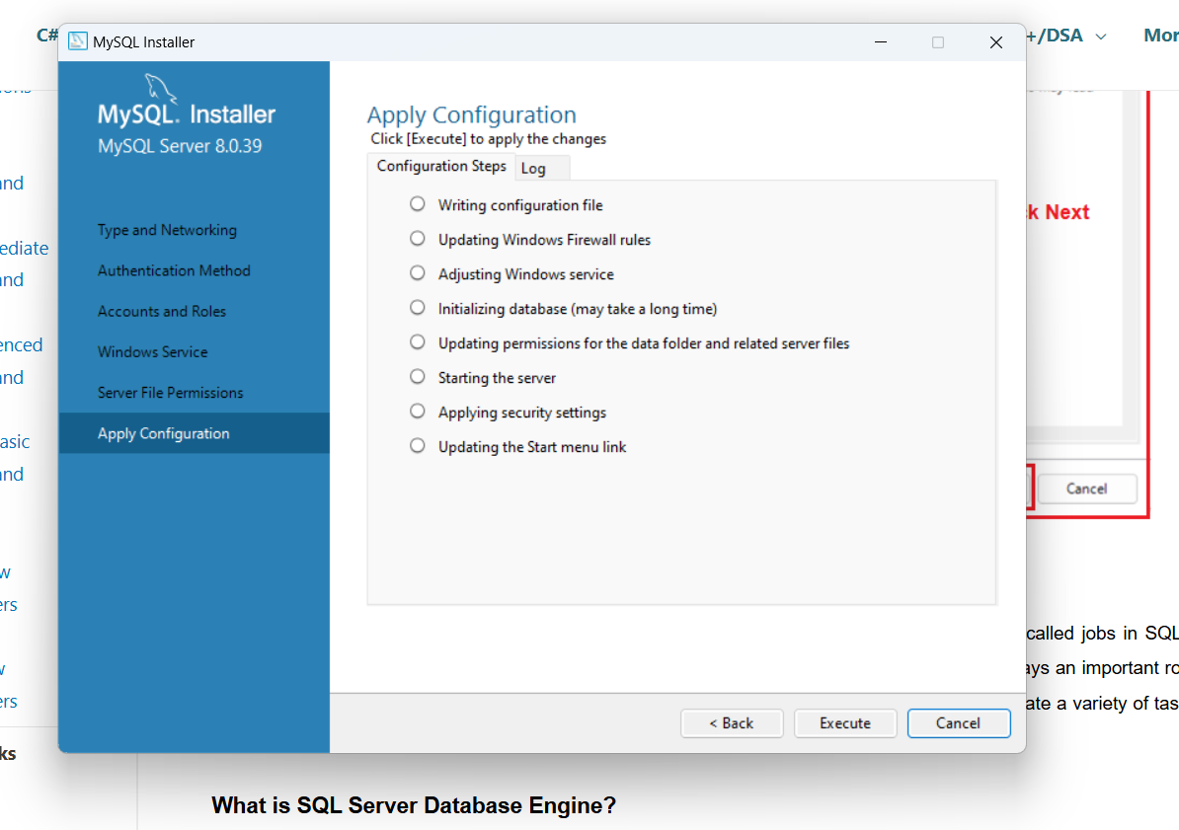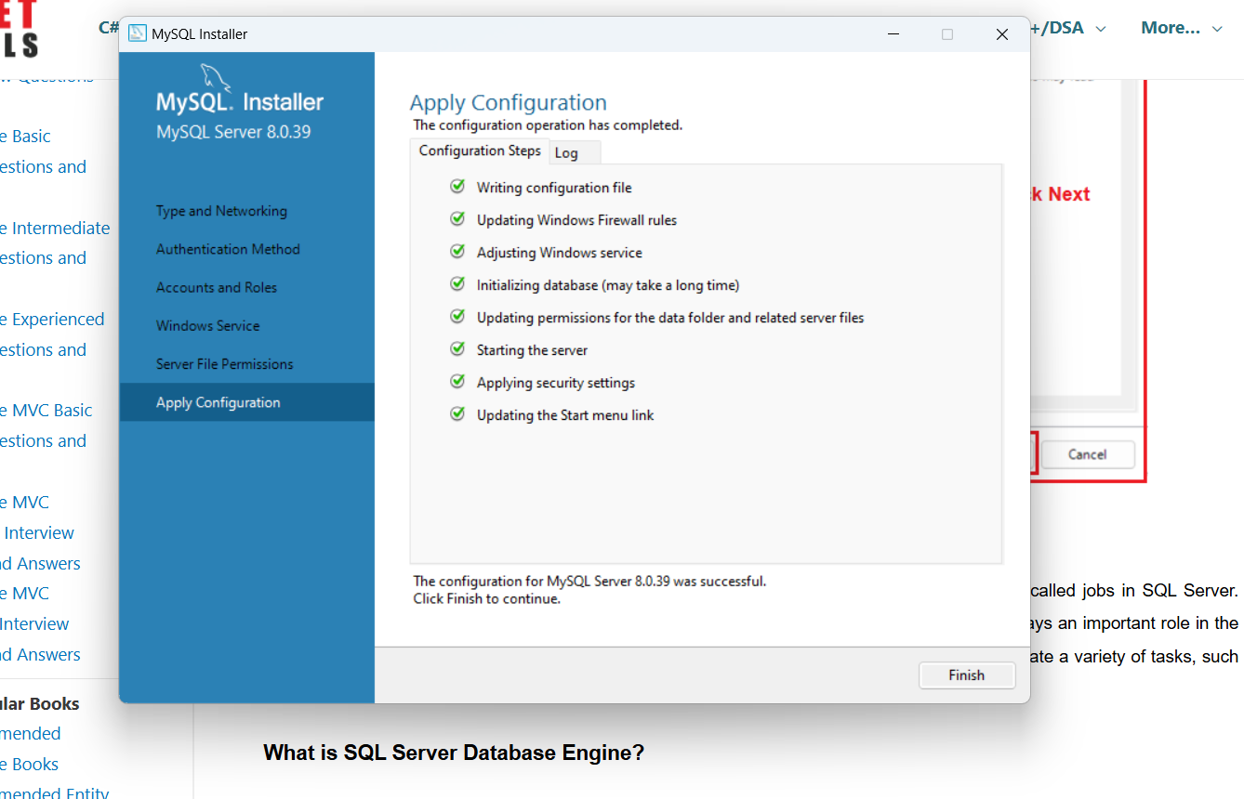
Figure 10- Configuration
11. After applying the configuration and finishing the configuration, your MySQL installation is completed.

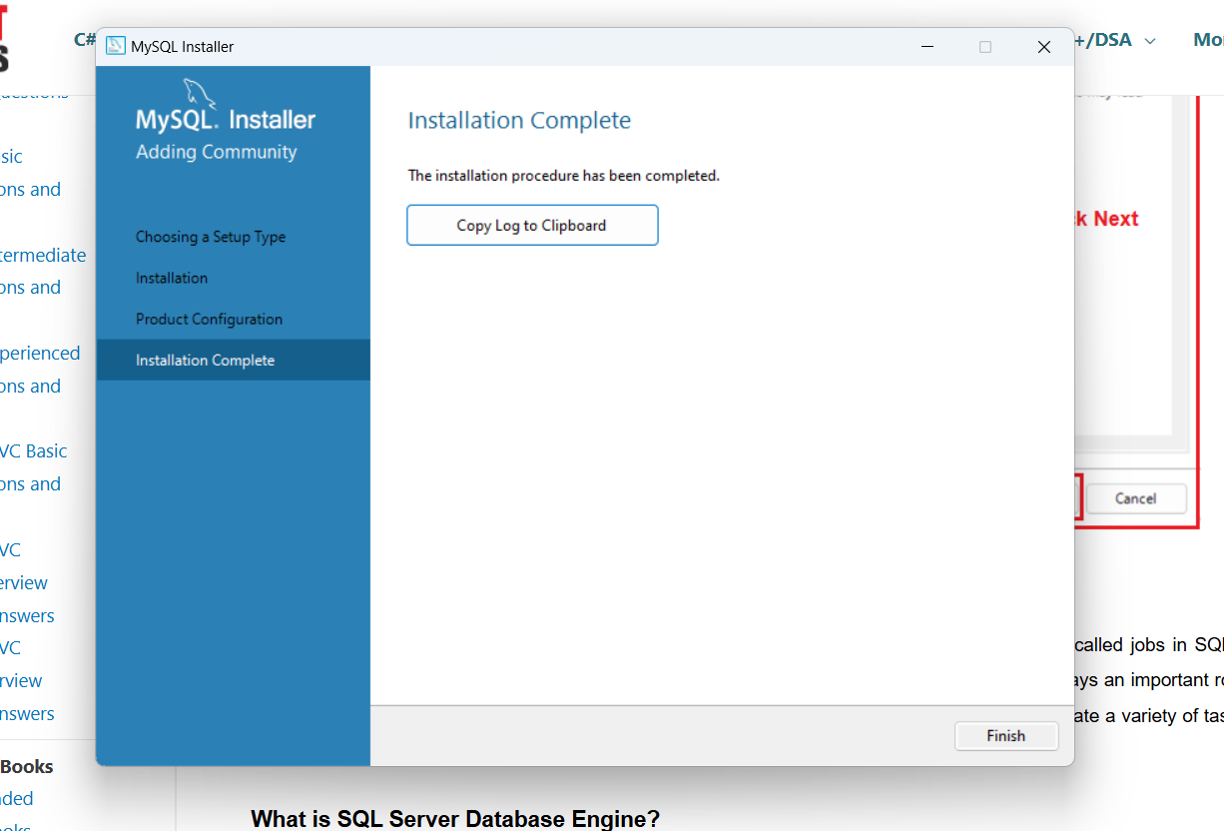
Figure 11- Installation completed
12. Now your setup is ready, so you can create your database.

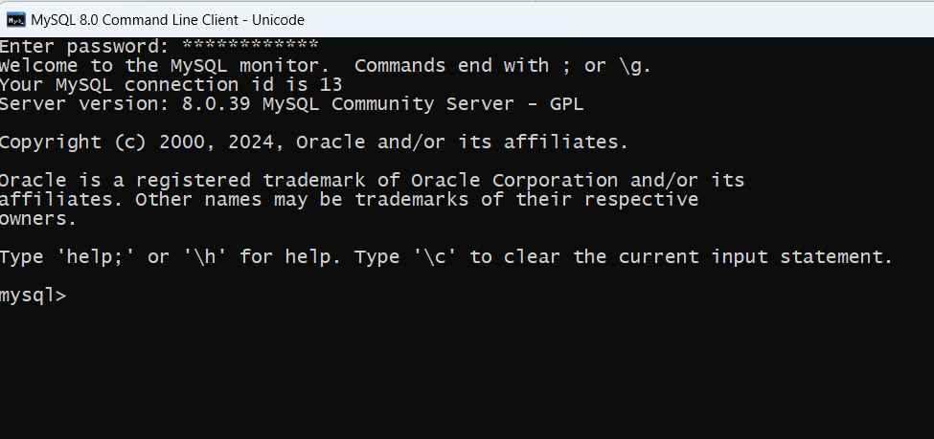
Figure 12- MySQL sever

 | Experiment Title: Data Types, Creating Tables, Retrieval of Rows using Select Statement, Conditional Retrieval of Rows, Alter and Drop Statements.
 | Laboratory: DBMS LAB
Experiment No: 2 | Department: | Semester:

- Data Types in MySQL
MySQL supports many basic data types. Data types are an essential part of working with databases. Knowing which different data types exist ensures each column gets an appropriate type assigned, leading to an optimized and error-free database.

What Are the Data Types in MySQL?

Every database column has a name and a data type. The specified data type tells MySQL what kind of values the column stores, how much space it requires, and what type of operations it can perform with the data.

A MySQL table can store many different data types. The most used types include:
- String Data Types:
  - CHAR(size): Fixed-length string (0 to 255 characters).
  - VARCHAR(size): Variable-length string (0 to 65535 characters).
  - ENUM(val1, val2, ...): String with a single value from a list.
  - SET(val1, val2, ...): String with multiple values from a list.
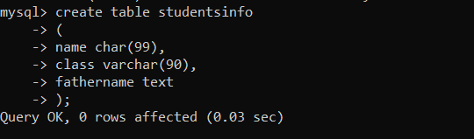
Figure 1.1-String Data Type
- Numeric Data Types:
- TINYINT(size): Represents very small integers. It can store values from -128 to 127 or 0 to 255 (if unsigned).
- SMALLINT(size): Stores small integers. The range is from -32768 to 32767 or 0 to 65535 (if unsigned).
- MEDIUMINT(size): Holds medium-sized integers, ranging from -8388608 to 8388607.
- INT(size) (or simply INTEGER): Commonly used for regular-sized integers, with a range from -2147483648 to 2147483647.
- BIGINT(size): For large integers, spanning from -9223372036854775808 to 9223372036854775807.
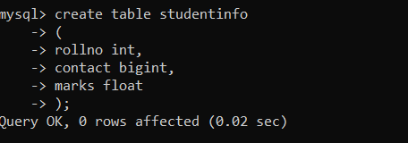
Figure 1.2- Numeric Data type
- Date and Time Data Types:
  - DATETIME: Date and time (YYYY-MM-DD HH:MM:SS).
  - TIMESTAMP: Similar to DATETIME.
  - DATE: Date (YYYY-MM-DD).
  - TIME: Time (HH:MM:SS).
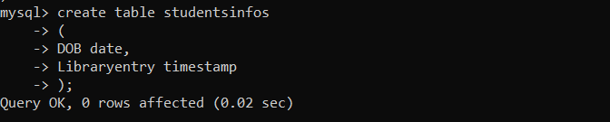
Figure 1.3- Date and Time Data Type
- Binary Data Types:
  - BINARY(size): Stores binary byte strings.
  - VARBINARY(size): Variable-length binary byte strings.
  - BLOB(size): Binary large objects (up to 65,535 bytes).
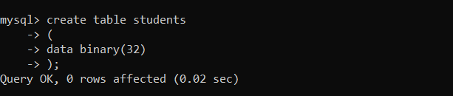
Figure 1.4- Binary Data Type
#Examples of Data Types used to create a table:

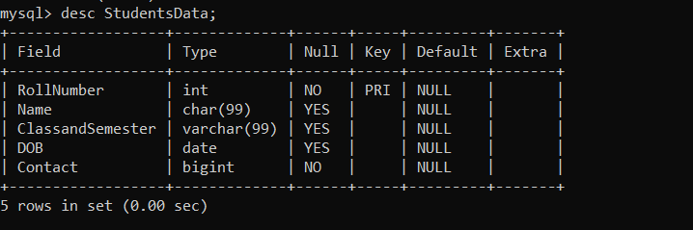
Figure 1.5- Data type MySQL
- Creating Tables in MySQL
Creating tables in MySQL is a fundamental task for organizing and managing data within a database. Tables act as structured containers, similar to spreadsheets, where data is stored in rows and columns.
MySQL Command Line Client allows you to create a table using the CREATE TABLE statement. This method requires specifying the table name, column names, and data types.

Syntax for creating table:
CREATE TABLE table_name (
column1 datatype,
column2 datatype,
column3 datatype,
....
);

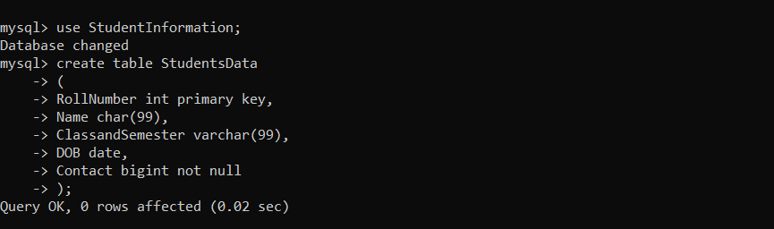
Figure 2.1- Creating Table MySQL

Inserting into table in MySQL
In MySQL, the INSERT INTO statement is essential for adding new data rows to a table in a database. This is important for setting up initial data in tables and for adding new records as needed when working with the database.

Syntax for inserting into table:
INSERT INTO table_name (column1, column2, column3, ...)
VALUES (value1, value2, value3, ...);

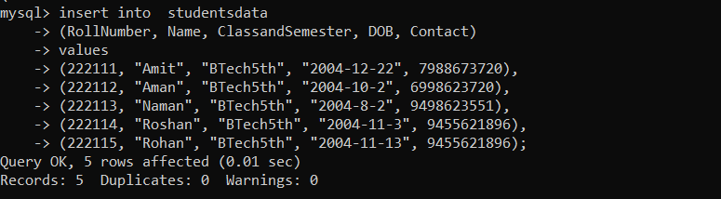
Figure 2.2- Inserting into Table in MySQL

MySQL SELECT STATEMENT
The MySQL SELECT statement is essential for fetching data from tables. It retrieves information and stores it in a result table, often referred to as a result set. Widely used in MySQL, SELECT is a fundamental command for querying databases.

SELECT Syntax :

#For selecting all Columns
SELECT * FROM table_name;
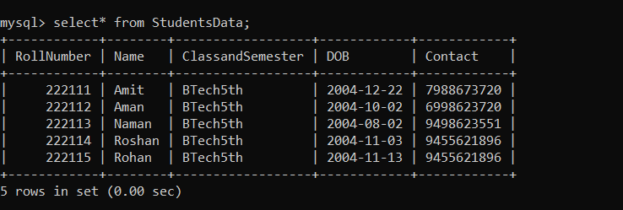
Figure 3.1- Select Statement

#For Selecting Specific Columns

SELECT column1, column2, ... FROM table_name;

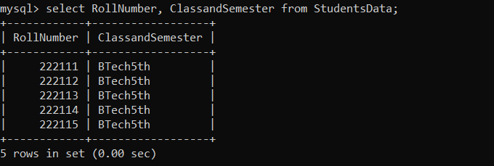
Figure 3.2- Select statement
#For Selecting a specific row
SELECT column1, column2, ...
FROM table_name
WHERE condition;
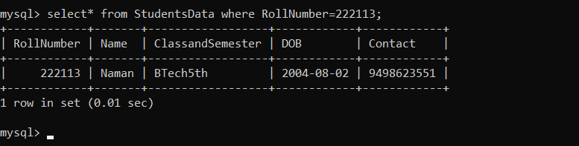
Figure 3.3- Select statement

#For Selecting distinct Statement
SELECT DISTINCT column1, column2, ...
FROM table_name;
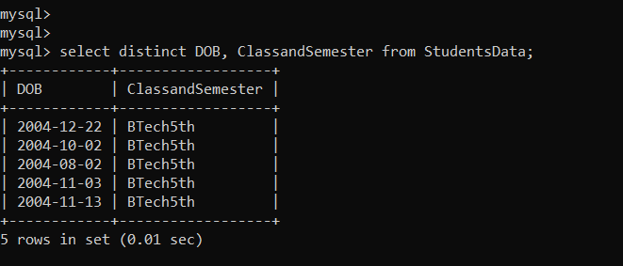
Figure 3.4- Select statement
- MySQL Alter and Drop Statement

MySQL Alter Table Statement:
The ALTER TABLE statement is used to add, delete, or modify columns in an existing table.
The ALTER TABLE statement is also used to add and drop various constraints on an existing table.

ALTER TABLE - ADD Column
To add a column in a table, use the following syntax:
ALTER TABLE table_name
ADD column_name datatype;
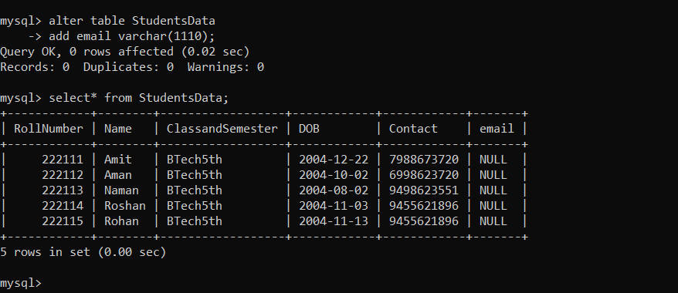
Figure 4.1- Add Column

ALTER TABLE - DROP Column
To delete a column in a table, use the following syntax :
ALTER TABLE table_name
DROP COLUMN column_name;
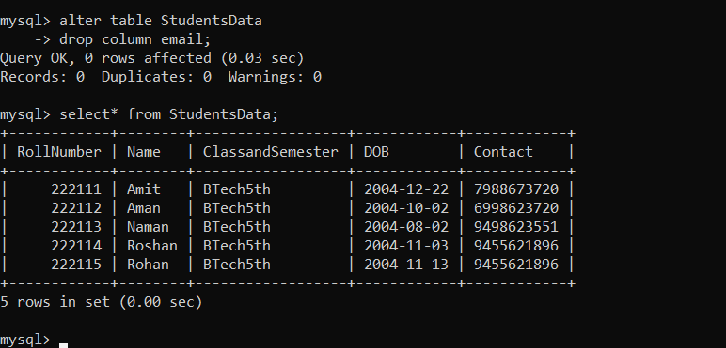
Figure 4.2- Drop Column

ALTER TABLE - MODIFY Column
To change the data type of a column in a table, use the following syntax:
ALTER TABLE table_name
MODIFY COLUMN column_name datatype;

- Before Name was char(99) but after modify statement it is now varchar(199);

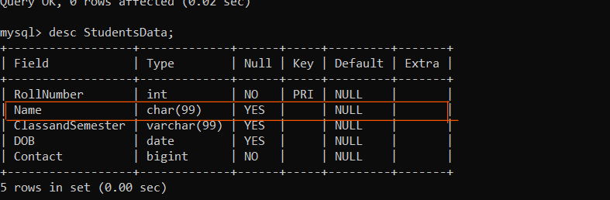
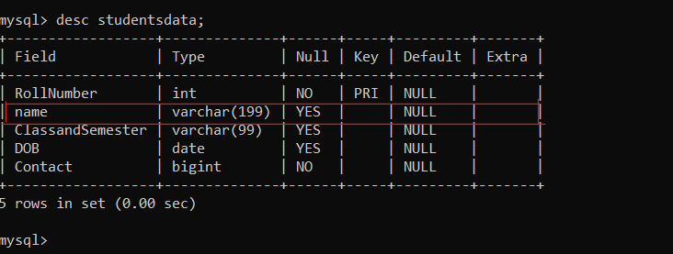
Figure 4.3-Modify Column

ALTER TABLE – RENAME COLUMN
To rename the data type of a column in a table, use the following syntax:
ALTER TABLE table_name
CHANGE COLUMN original_name new_name column_definition
[FIRST | AFTER column_name];

- Before it was just name after rename it was StudentsName;

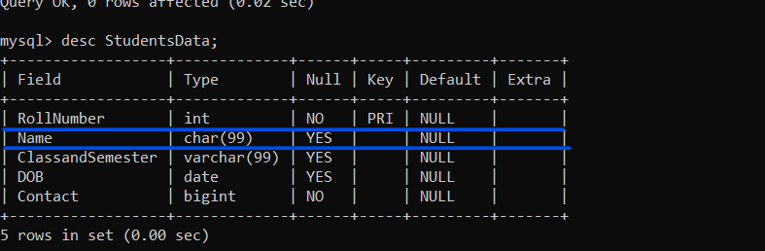
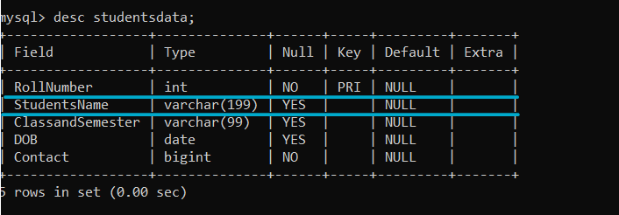
Figure 4.4- Rename Table

MySQL DROP Statements:
In Database Management Systems managing databases involves not only creating and modifying the data but also removing the databases when they are no longer needed and freeing the space occupied by them. MySQL offers a feature called DROP, allowing users to delete databases.

MySQL DROP DATABASE Statement
The DROP DATABASE statement is used to drop an existing SQL database.

Syntax
DROP TABLE table_name;

NOTE: The DROP DATABASE command in MySQL is an important tool used to permanently delete an entire database and it also deletes the data, tables, views, and stored procedures that are associated with the database. The DROP DATABASE command is irreversible and can result in the loss of critical data if not used properly. Due to this, the dropping of the database should be executed with care as it erases all information within the specified database.

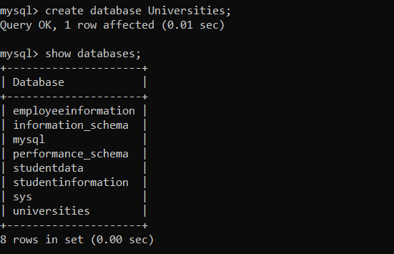
Figure 4.5- Creating a database
#So let us drop the database created which is Universities:

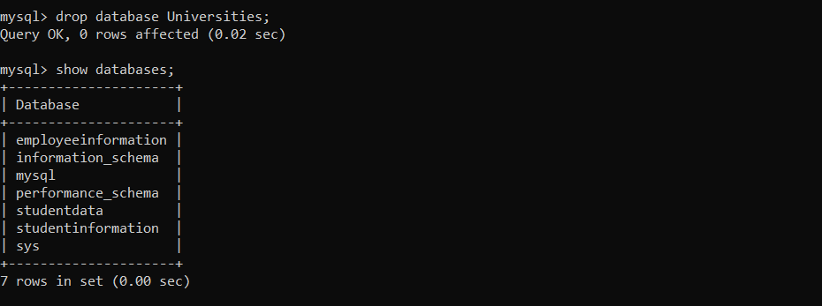
Figure 4.6- Drop database

MySQL DROP TABLE Statement
The DROP TABLE statement is used to drop an existing table in a database.

Syntax
DROP TABLE table_name;

NOTE: The DROP TABLE statement drops one or more existing tables from the database. It removes the table definition and all the data inside the table.

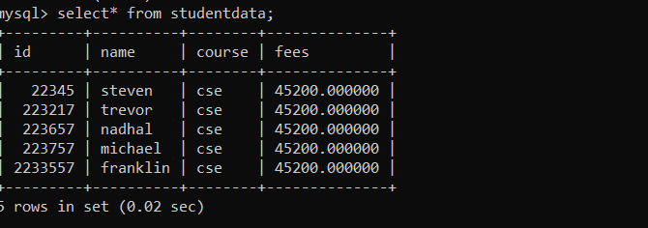
Figure 4.7- Selecting a table
#So let us drop a table from a particular database;

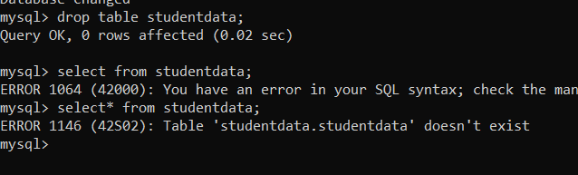
Figure 4.8- Drop a table

 | Experiment Title: Working with Null Values, Matching a Pattern from a Table, Ordering the Result of a Query, Aggregate Functions, Grouping the Result of a Query, Update and Delete Statements.
 | Laboratory: DBMS LAB
Experiment No: 3 | Department: | Semester:

- Working with Null Values, Order BY Clause

MySQL NULL Values:
A field with a NULL value is a field with no value.
If a field in a table is optional, it is possible to insert a new record or update a record without adding a value to this field. Then, the field will be saved with a NULL value.

NULL Value Syntax

column_name data_type NULL;

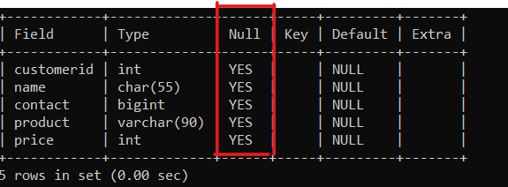
Figure 1.1- NULL Values

MySQL NOT NULL Values:
The NOT NULL constraint enforces a column to NOT accept NULL values.
This enforces a field to always contain a value, which means that you cannot insert a new record, or update a record without adding a value to this field.

NOT NULL Value Syntax
column_name data_type NOT NULL;
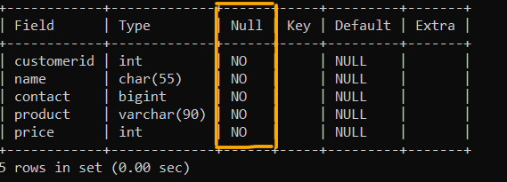
Figure 1.2- NOT NULL Values

MySQL ORDER BY Clause

The ORDER BY Clause in MySQL is a powerful tool that allows you to sort the result set of a query in ascending or descending order based on one or more columns.
It is an essential part of querying databases when you want to retrieve data in a specific order.
Where,
ASC (default): Sorts the result set in ascending order.
DESC: Sorts the result set in descending order.

ORDER BY Syntax
SELECT column1, column2, ...
FROM table_name
ORDER BY column1, column2, ... ASC|DESC;

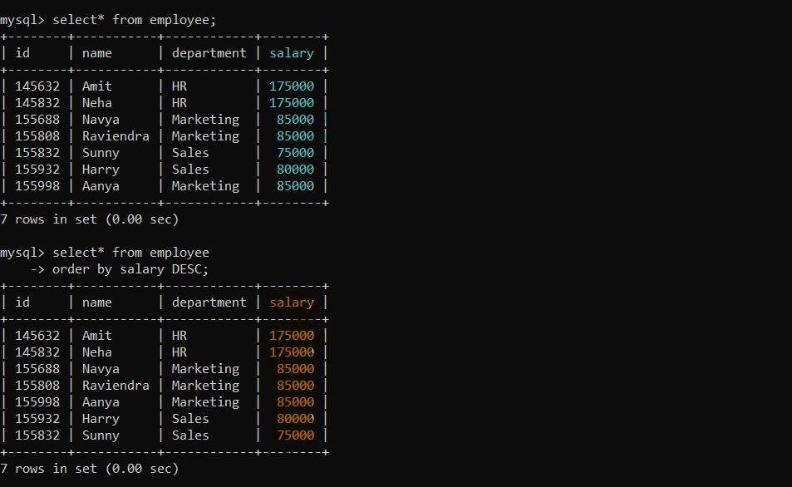

- MySQL Aggregate Functions
Aggregate functions in MySQL process a set of values and return a single value. They are typically used with the SELECT statement and can be applied to various columns within a table. Common aggregate functions include COUNT(), SUM(), AVG(), MAX(), and MIN(). These functions provide essential tools for summarizing and analyzing data efficiently.
SELECT Aggrete function(column_name)
FROM table_name
WHERE condition;
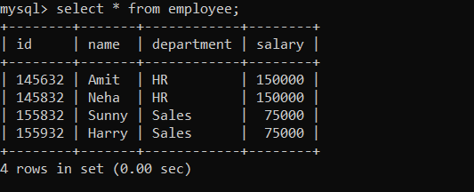
Figure 2.1- Database

Common Aggregate Functions

COUNT()
The COUNT() function returns the number of rows that match a specified condition. It can count all rows or only rows that meet certain criteria.

COUNT() Syntax
SELECT COUNT(column_name)
FROM table_name
WHERE condition;

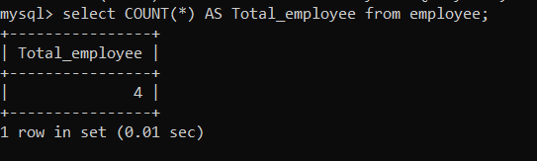
Figure 2.2-Count Function

SUM()
The SUM() function returns the total sum of a numeric column.

SUM() Syntax

SELECT SUM(column_name)
FROM table_name
WHERE condition;

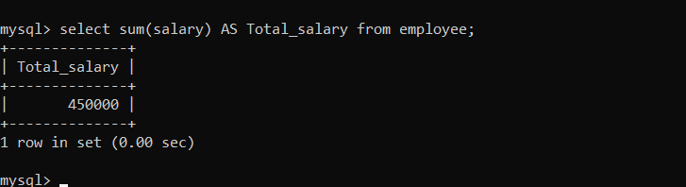
Figure 2.2- Sum Function

AVG()
The AVG() function returns the average value of a numeric column.

AVG() Syntax

SELECT AVG(column_name)
FROM table_name
WHERE condition;

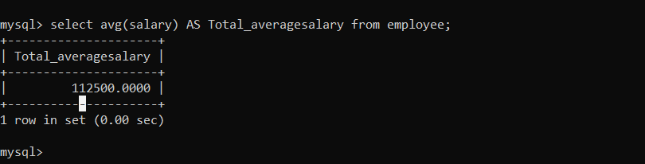
Figure 2.3- Average Function

MAX()
The MAX() function returns the maximum value in a set of values.

MAX() Syntax
SELECT MAX(column_name)
FROM table_name
WHERE condition;

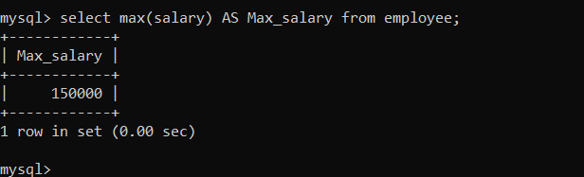
Figure 2.4-Maximum Function

MIN()
The MIN() function returns the minimum value in a set of values.

MIN() Syntax

SELECT MIN(column_name)
FROM table_name
WHERE condition;
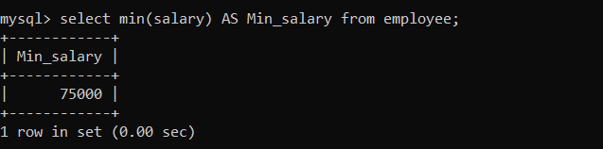
Figure 2.5-Minimum Function

- Update and Delete Statements.
In any database management system, updating and deleting data are essential operations to manage and maintain the integrity of the data. MySQL, one of the most popular and widely used relational database management systems, provides powerful statements to perform these tasks efficiently: UPDATE and DELETE.

MySQL UPDATE Statement
The UPDATE statement in MySQL is used to modify existing records or data in a table. It is commonly used to correct any errors previously made or update the values of a column. It’s important to remember that changes made through the UPDATE statement are permanent and cannot be undone.

UPDATE Syntax
UPDATE table_name
SET column1 = value1, column2 = value2, ...
WHERE condition;

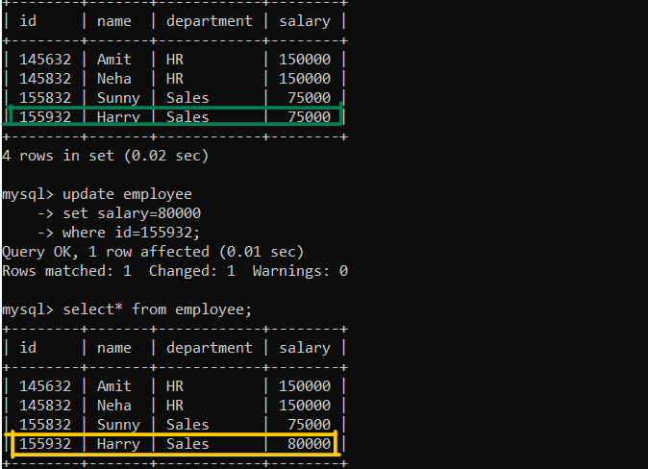
Figure 3.1- Update Statement

UPDATE Multiple Records

It is the WHERE clause that determines how many records will be updated.
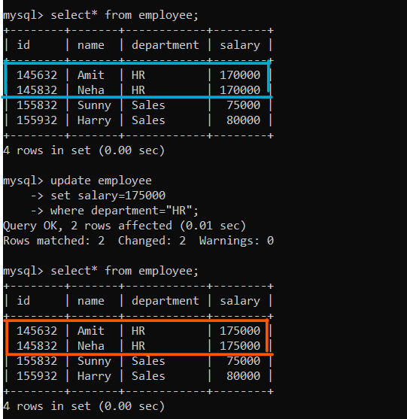
Figure 3.2-Update Multiple Records

MySQL DELETE Statement
The MySQL DELETE statement deletes one or more existing records from a table. It is commonly used with the WHERE or JOIN clause. It is a Data Manipulation Language (DML) statement. Generally, you cannot ROLLBACK (undo) after performing the DELETE statement. You can delete the entire table data using DELETE or delete only specific rows.

DELETE Syntax
DELETE FROM table_name WHERE condition;

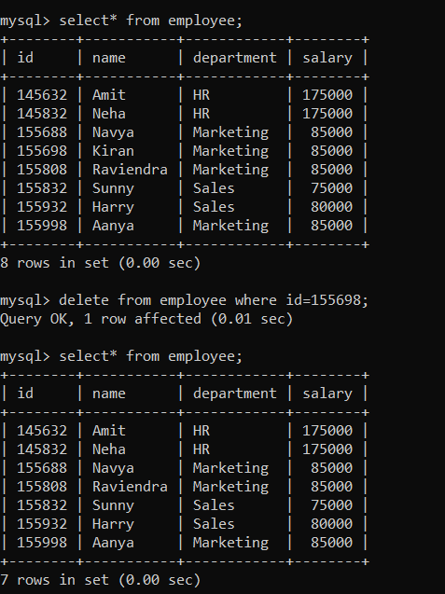
Figure 3.3- Delete Statement

DELETE All Records

It is possible to delete all rows in a table without deleting the table. This means that the table structure, attributes, and indexes will be intact.

DELETE All Records Syntax
DELETE FROM table_name;

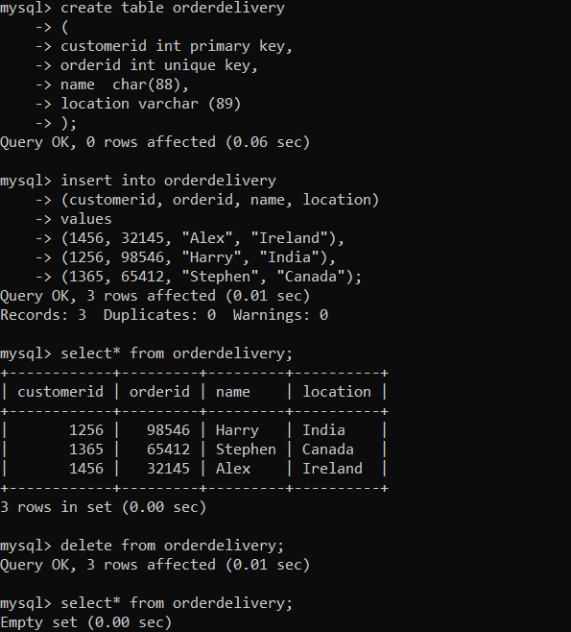
Figure 3.4- Delete All Records Statements
- Matching a Pattern from a Table, Grouping the Result of a Query

Pattern Matching in MySQL
Pattern matching is a key component of database management, allowing users to find and retrieve data within their domain of interest quickly. Pattern matching in MySQL primarily revolves around two key operators: LIKE and REGEXP. Such operators allow text sorting within text field types like strings and characters.

LIKE Operator:
This LIKE operator may be the one most often used in MySQL queries to run pattern matching. It finds an exact match to the given pattern inside the string. Pattern structure will comprise wildcards to represent any number of symbols or a single symbol.
- ‘%’ Wildcard: The percent sign ‘%’ denotes zero or more characters. As an example, ‘%apple’ obtains any string that begins with ‘%apple’, followed by zero or more characters.
- ” Wildcard: Underscore ” is used to show a character’s presence. For instance, ‘c_t’ corresponds to ‘cat, cot, cut’, etc.
- Combination: Adding ‘%’ and ‘_’ together allows for a more complicated form. For example, ‘a%e’ matches any string that began with ‘a’ and ended with ‘e’.
Syntax
SELECT column1, column2, ...
FROM table_name
WHERE columnN LIKE pattern;

REGEXP Operator
The REGEXP operator gives a more complex matching option by utilizing regular expressions for matching patterns. Regular expressions are powerful pattern-matching tools that allow for sophisticated searches involving complicated and specific patterns within text data.
- Character Classes: Regular expressions will include character classes such as [a-z] for any lowercase letter and [0-9] for any digit.
- Quantifiers: Quantifiers specify the number of occurrences of a character or group, such as ‘*’ for zero or more occurrences and ‘+’ for one or more occurrences.
- Anchors: Anchors specify the position of a pattern within a string, such as ‘^’ for the start of a string and ‘$’ for the end of a string.

Using the LIKE Operator

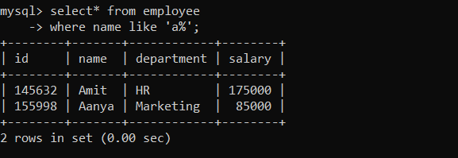
Figure 4.1 Like operator

Using the REGEXP Operator

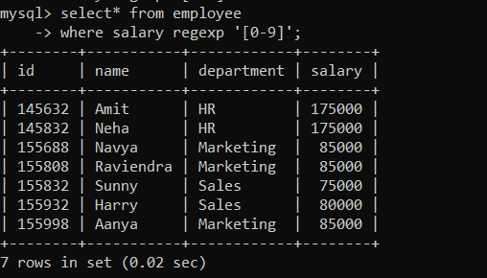
Figure 4.2- REGEXP operator

Using LIKE with ‘%’ and ‘_’:

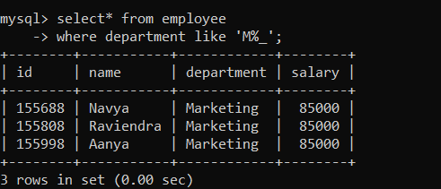
Figure 4.3- Like and Wildcard_

MySQL GROUP BY Statement
The GROUP BY clause groups rows into summary rows based on column values or expressions. It returns one row for each group and reduces the number of rows in the result set.

Syntax
SELECT column_name(s)
FROM table_name
WHERE condition
GROUP BY column_name(s)
ORDER BY column_name(s);

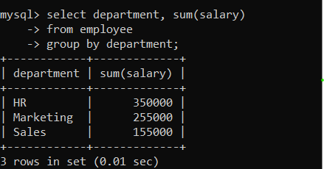
Figure 4.4- Group by Statement

MySQL HAVING Statement
The HAVING clause was added to SQL because the WHERE keyword cannot be used with aggregate functions.

Syntax
SELECT column_name(s)
FROM table_name
WHERE condition
GROUP BY column_name(s)
HAVING condition
ORDER BY column_name(s);

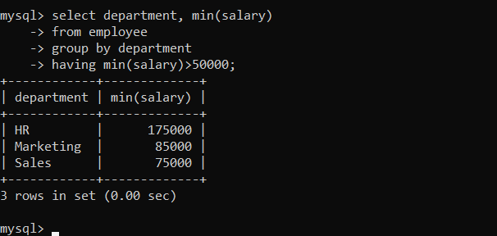
Figure 4.5- Having statement

 | Experiment Title: Set Operators, Nested Queries, Joins, Sequences.
 | Laboratory: DBMS LAB
Experiment No: 4 | Department: | Semester:

- Set Operator in MySQL

Set Operators
Relational databases employ set operators to modify and compare data sets. Simply put, a set operator creates a new set of data that satisfies particular requirements by combining or comparing two or more data sets.
The frequently used to set operators in MySQL are: UNION, UNION ALL, INTERSECT, and EXCEPT. With these operators, the output of two or more SELECT statements can be combined or compared.

UNION Operator
The UNION operator is one of the most often-used set operators in MySQL. It combines the results of two or more SELECT operations into a single result set.
Union Syntax
SELECT column1, column2, ...
FROM table1
UNION
SELECT column1, column2, ...
FROM table2

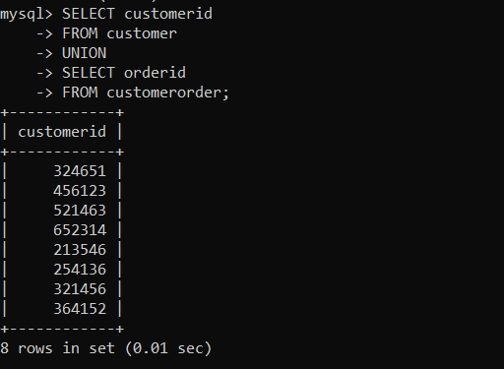
Figure 1.1- UNION

UNION ALL Operator
In SQL, the UNION ALL operator merges the results of many SELECT operations into a single result set. The UNION ALL operator is similar to the UNION operator, with one major difference: UNION ALL does not eliminate duplicates from the result set. It instead returns all the records of both SELECT statements, including the duplicates.

UNION ALL Syntax
SELECT column1, column2, ...
FROM table1
UNION ALL
SELECT column1, column2, ...
FROM table2;

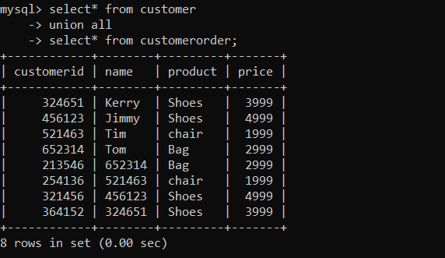
Figure 1.2- UNION ALL
INTERSECT Operator
In SQL queries, the INTERSECT operator is useful for determining the intersection of two result sets. It takes the output of two SELECT operations and returns only the rows that occur in both sets. In other words, the INTERSECT operator is used to locate records shared by two tables.

Intersect Syntax
SELECT column1, column2, ...
FROM table1
INTERSECT
SELECT column1, column2, ...
FROM table2;
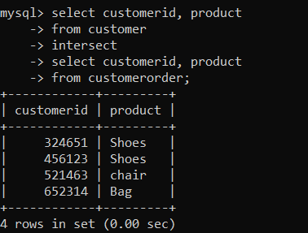
Figure 1.3- Intersect
EXCEPT Operator
The EXCEPT operator is used to deduct the results of one query from the results of another. In other words, it only returns the entries unique to the first query and which do not appear in the second query.

Except Syntax
SELECT column1, column2, ...
FROM table1
EXCEPT
SELECT column1, column2, ...
FROM table2;

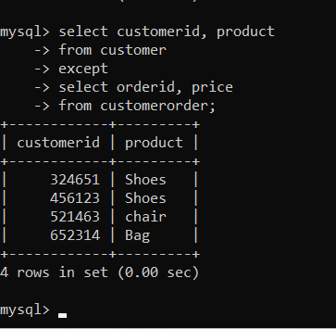
Figure 1.4- Except

- JOINS
MySQL JOIN is a fundamental feature that combines rows from two or more tables based on a related column between them. It allows for efficient data retrieval by enabling the extraction of related information from multiple tables in a single query.

Supported Types of Joins in MySQL
- INNER JOIN: Returns records that have matching values in both tables
- LEFT JOIN: Returns all records from the left table, and the matched records from the right table
- RIGHT JOIN: Returns all records from the right table, and the matched records from the left table
- CROSS JOIN: Returns all records from both tables
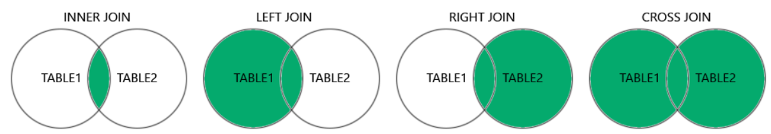
Figure 2.1- Joins in MySQL

MySQL INNER JOIN

The INNER JOIN keyword selects records that have matching values in both tables.

INNER JOIN Syntax
SELECT column_name(s)
FROM table1
INNER JOIN table2
ON table1.column_name = table2.column_name;

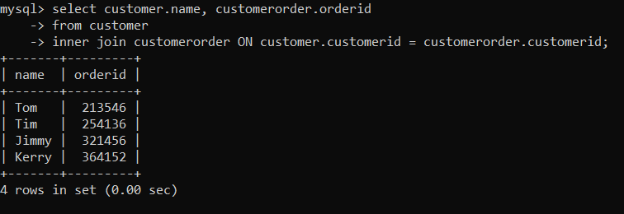
Figure 2.2- Inner join

MySQL CROSS JOIN
Cross JOIN is a simplest form of JOINs which matches each row from one database table to all rows of another.
In other words it gives us combinations of each row of first table with all records in second table.

CROSS JOIN Syntax
SELECT column_name(s)
FROM table1
CROSS JOIN table2;

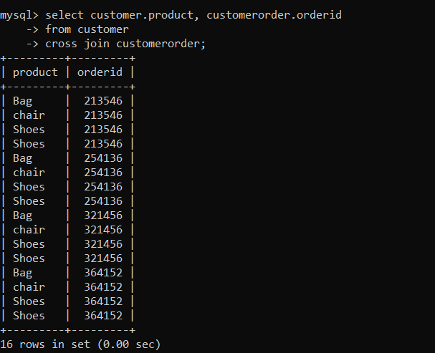
Figure 2.3- Cross Join
MySQL RIGHT JOIN
It Returns all the rows from the right table and the matched rows from the left table. NULL values will be returned for columns from the left table when there are no matches.

RIGHT JOIN Syntax
SELECT column_name(s)
FROM table1
RIGHT JOIN table2
ON table1.column_name = table2.column_name;

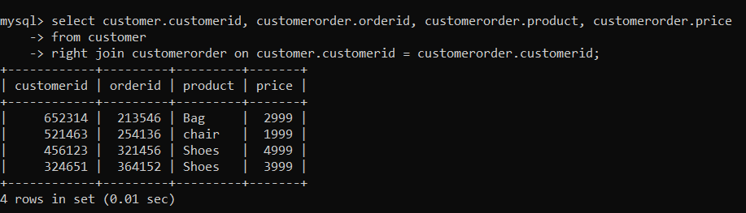
Figure 2.4- Right Join

MySQL LEFT JOIN
It returns all records from the Left table and matched records from the Right table. If there is no match, then NULL values are returned for Right table columns.

LEFT JOIN Syntax
SELECT column_name(s)
FROM table1
LEFT JOIN table2
ON table1.column_name = table2.column_name;

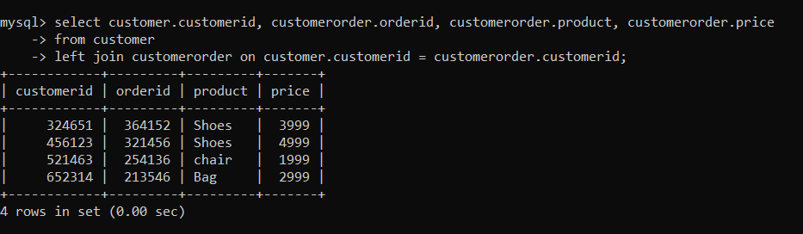
Figure 2.5- Left Join

- Nested Queries, Sequences in MySQL

Sequences in MySQL
MySQL does not have a built-in sequence feature but provides an alternative in the form of the AUTO_INCREMENT column, which serves a similar purpose.
In MySQL, the AUTO_INCREMENT attribute is used to automatically generate unique integer values (sequences) for a column. By default, this sequence begins with an initial value of 1 and increments by 1 for each new row that is added.

Sequences Syntax
CREATE TABLE table_name (
column1 datatype AUTO_INCREMENT,
column2 datatype,
column3 datatype,
...
columnN datatype
);

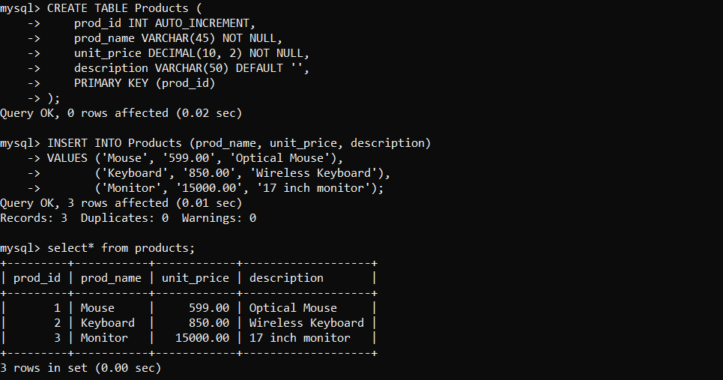
Figure 3.1- Sequences in MySQL
Deleting a Value from table
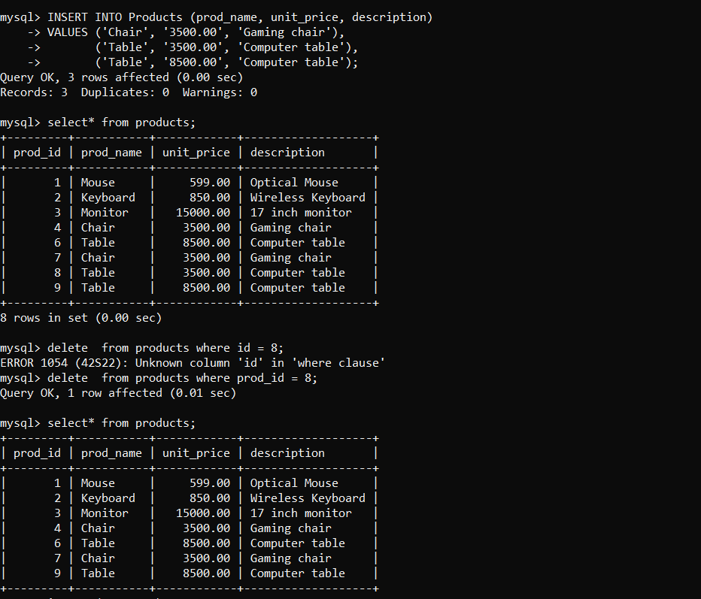
Figure 5.2- Deleting a value

Nested Query in MySQL

The MySQL subquery, also known as an inner query or nested query, is a query inside another query. It allows you to retrieve data from one or more tables based on the results of another query. Subqueries can be used in various parts of SQL statements, including SELECT, INSERT, UPDATE, and DELETE.

Subquery with the SELECT Statement
A subquery within a SELECT statement is used to filter the results of the main query based on the values retrieved from the subquery.

Syntax
SELECT column1, column2, ...
FROM table1
WHERE columnN operator
(SELECT column_name FROM table2 WHERE condition);

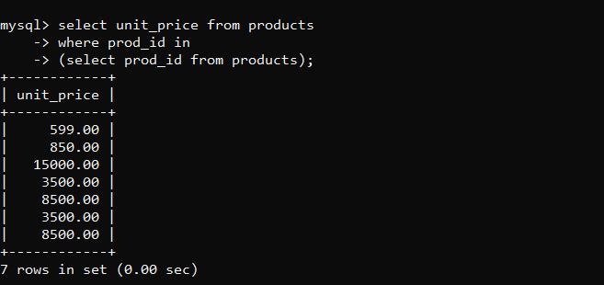
Figure 3.3 Select Subquery

Subquery with Comparison Operator
The MySQL Subquery with comparison operator allows us to use a query inside another query and compare its result with the outer query using comparison operators.

Syntax
SELECT column_name [, column_name ]
FROM table1 [, table2 ]
WHERE column_name OPERATOR
(SELECT column_name [, column_name ]
FROM table1 [, table2 ]
[WHERE] .....)

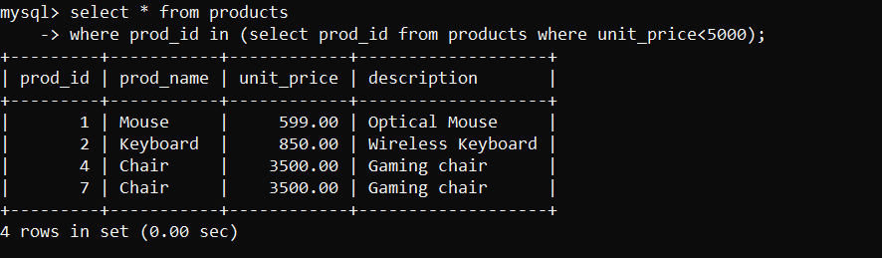
Figure 3.4 Comparison operator

Subquery with IN or NOT-IN Operator
The MySQL subqueries with IN/NOT-IN operators are used to filter data based on whether values from one query match or do not match values from another query −
- IN matches any value from the list
- NOT-IN excludes any value from the list.

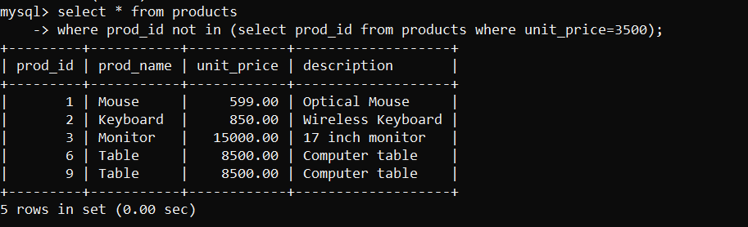
Figure 3.5- Not In Statement
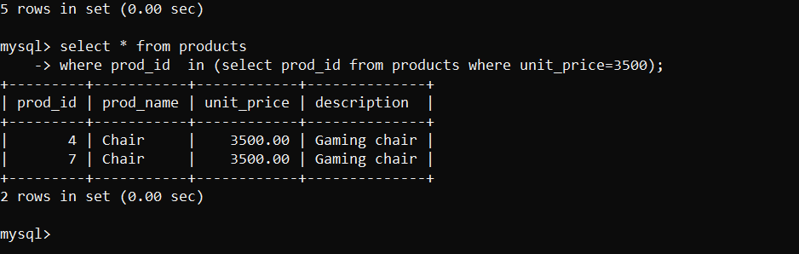
Figure 3.6- In Statement

 | Experiment Title: Views, Indexes, Database Security and Privileges: Grant and Revoke Commands, Commit and Rollback Commands.
 | Laboratory: DBMS LAB
Experiment No: 5 | Department: | Semester:

MySQL Views, Indexes

MySQL Views
Views in MySQL are virtual tables that represent the result-set of a stored SQL query. They are not physical tables but appear as ordinary tables to SELECT statements. Views can encapsulate complex queries with joins, filters, and calculations, presenting the data as if it were coming from a single table. This abstraction can simplify data access and provide additional security layers by restricting access to underlying table data.

What is the Benefit of Using Views in MySQL?

- Simplicity: Instead of writing complex joins & queries, views provide a way of writing simple SELECT statements.
- Enhanced Security: Views expose only the data to the third-party apps and hide the internal details like table structure, attributes, etc, thus adding extra security.
- Consistency: By writing views instead of common queries, we can write a view that avoids multiple declarations & definitions of the same queries and eventually provides a centralized way.

MySQL CREATE VIEW Statement
A view in MySQL can be created based on a single table or multiple tables. The CREATE VIEW statement is used to create a view in MYSQL.

CREATE VIEW Syntax
CREATE VIEW view_name AS
SELECT column1, column2, ...
FROM table_name
WHERE condition;

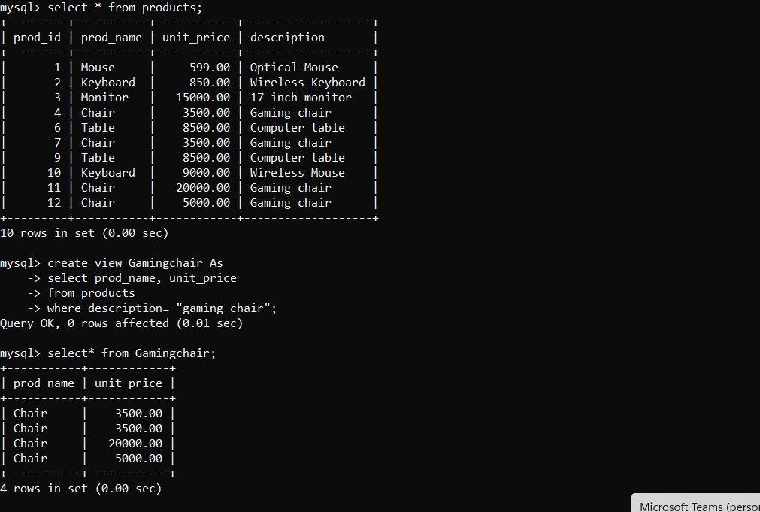
Figure 1.1 Create view

Update View in MySQL
There are certain conditions that need to be satisfied to update a view. If any one of these conditions is not met, then we are not allowed to update the view.
- The View should be created from a single table. If the view is created using multiple tables then we will not be allowed to update the view.
- The View should not be created using nested queries or complex queries.
- The View should have all NOT NULL values.
- The SELECT statement should not have the DISTINCT keyword.
- The SELECT statement which is used to create the view should not include GROUP BY clause or ORDER BY clause.

Update View
To update the view for adding or remove columns and rows by changing WHERE clause condition, we can use CREATE OR REPLACE VIEW statement.

Update Syntax
CREATE OR REPLACE VIEW view_name AS
SELECT column1, column2, ...
FROM table_name
WHERE condition;

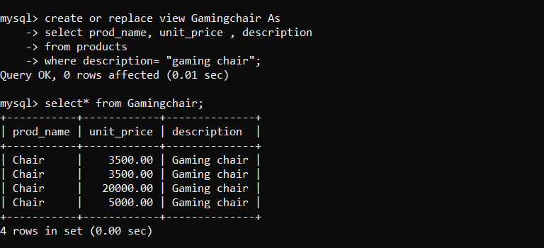
Figure 1.2 Update view

Insert Into View
To insert the new row into the view, we can do it in a similar way just like how we do it for normal tables.

Insert Syntax:
INSERT INTO <view_name>(<column1>, <column2>, <column3>,.........)
VALUES(<value1>, <value2>, <value3>,...........);
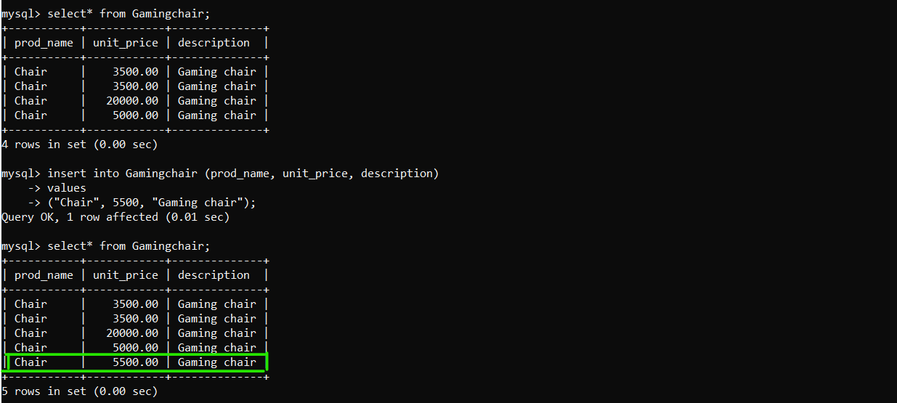
Figure 1.3 Insert view

Delete From View

To delete the row into the view, we can do it in a similar way just like how we do it for normal tables.

Delete Syntax
DELETE FROM <view_name> WHERE [condition];

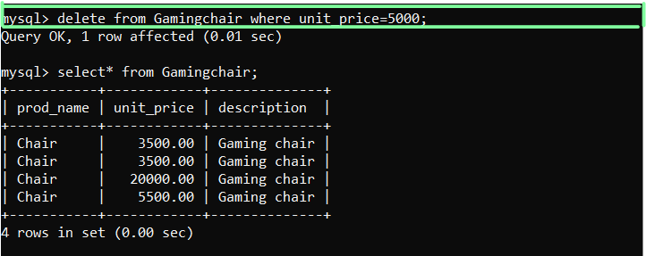
Figure 1.4 Delete view

Drop View in MySQL
MySQL allows to deletion an already existing view. We can drop a view using the DROP statement.

Drop Syntax
DROP VIEW <view_name>;

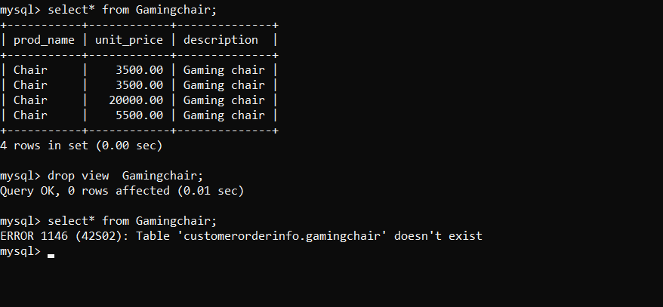
Figure 1.5 Drop view

MySQL Indexes
MySQL indexes are designed tools to increase the speed and efficiency of data retrieval operations within a database. Similar to a book index, which helps a user get to the information without having to go page after page, MySQL indexes let the database quickly find and retrieve your required data without scanning the whole table. MySQL index allows the database to locate and access rows in a table much faster than it could without an index.

MySQL CREATE INDEX Statement
The CREATE INDEX statement is used to create indexes in tables.
Indexes are used to retrieve data from the database more quickly than otherwise. The users cannot see the indexes, they are just used to speed up searches/queries.

CREATE INDEX Syntax
CREATE INDEX index_name
ON table_name (column1, column2, ...);

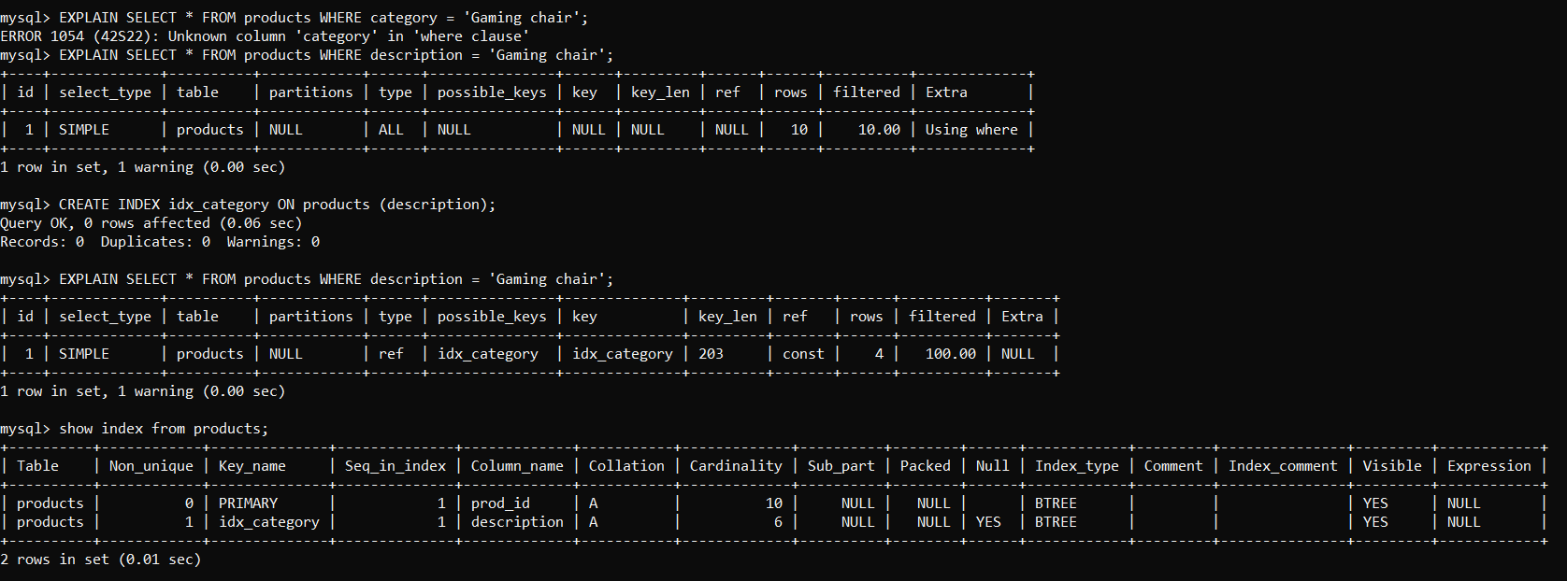
Figure 1.6- Create Index

DROP INDEX Statement
The DROP INDEX statement in MySQL is used to delete an existing index from a table. Removing unnecessary or redundant indexes can help optimize database performance and manage storage effectively.

Syntax DROP INDEX

ALTER TABLE table_name
DROP INDEX index_name;

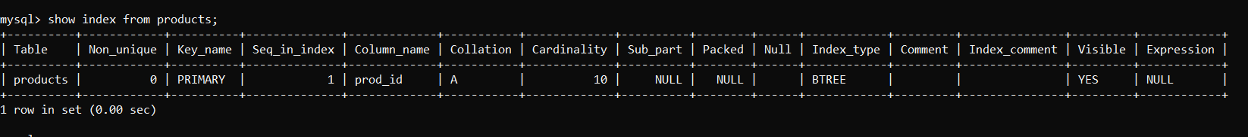
Figure 1.7 Drop index
- Grant and Revoke Commands
Managing user access and privileges is a crucial aspect of database administration in MySQL. After creating a user account with the CREATE USER statement, the next step is to define what that user can do within the database.This is achieved through the GRANT statement, which allows administrators to assign specific privileges to users and ensure they can perform only the actions necessary for their roles. Also, if a user’s access needs to be restricted, the REVOKE statement can remove previously granted privileges.

Grant command
The grant statement enables system administrators to assign privileges and roles to the MySQL user accounts so that they can use the assigned permission on the database whenever required.

Syntax:
GRANT privileges_names ON object TO user;

Types of Privileges
Privileges: The privileges that can be granted to the users are listed below along with the description:

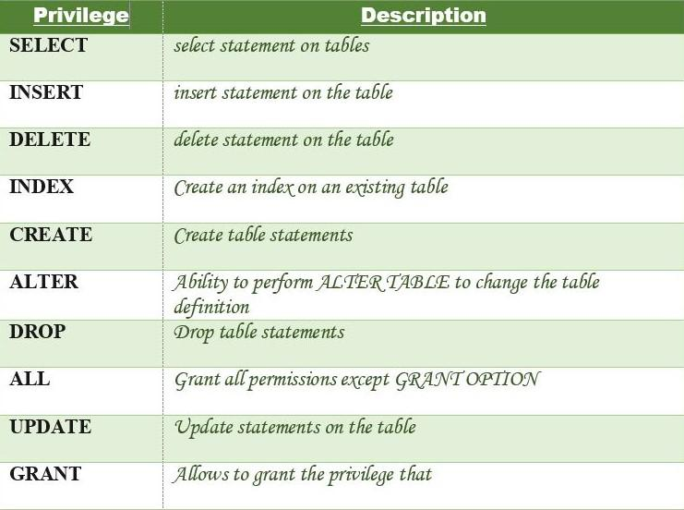

Granting Privileges to Users
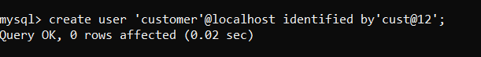

#Examples of grant statement:

Granting Privilege to a User
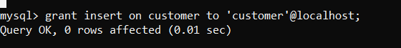
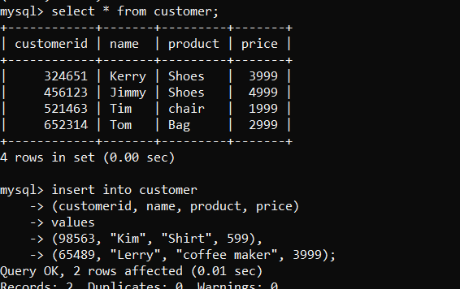
Figure 2.1 Grant privileges statement

Granting Multiple Privileges

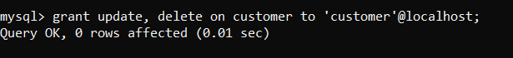

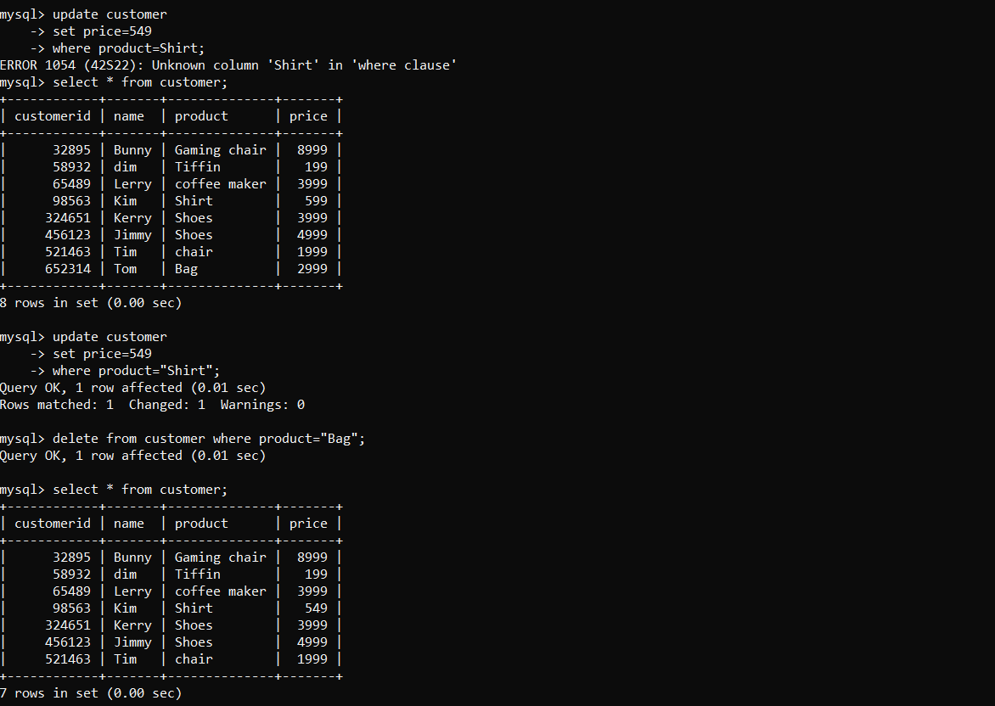
Figure 2.2 Multiple privileges
Revoke Commands
The Revoke statement is used to revoke some or all of the privileges which have been granted to a user in the past.

Syntax:
REVOKE privileges ON object FROM user;

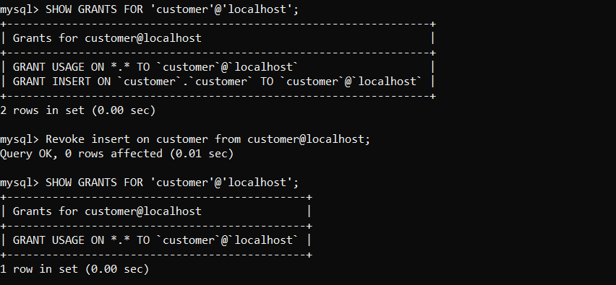
Figure 2.3 Revoke statement

Commit and Rollback Commands in MySQL

COMMIT command
COMMIT command is used to permanently save any transaction into the database.
When we use any DML command like INSERT, UPDATE or DELETE, the changes made by these commands are not permanent, until the current session is closed, the changes made by these commands can be rolled back.
To avoid that, we use the COMMIT command to mark the changes as permanent.
Commit Syntax
COMMIT;

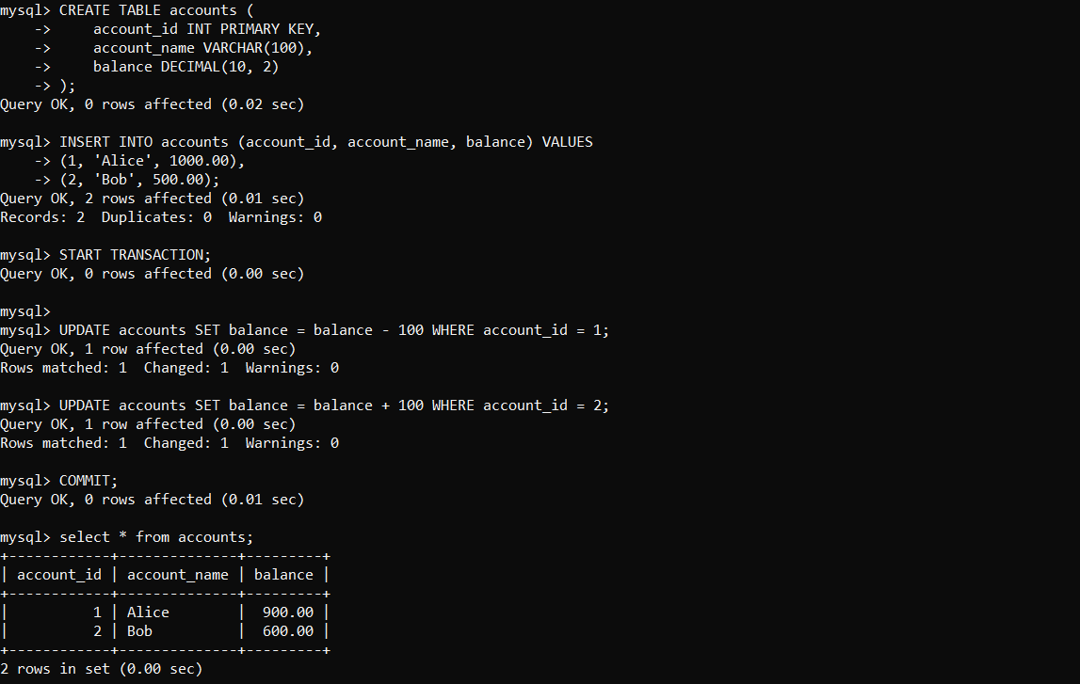
Figure 3.1 Commit

ROLLBACK command
This command restores the database to last commited state. It is also used with SAVEPOINT command to jump to a savepoint in an ongoing transaction.
If we have used the UPDATE command to make some changes into the database, and realise that those changes were not required, then we can use the ROLLBACK command to rollback those changes, if they were not commited using the COMMIT command.
Rollback Syntax
ROLLBACK;
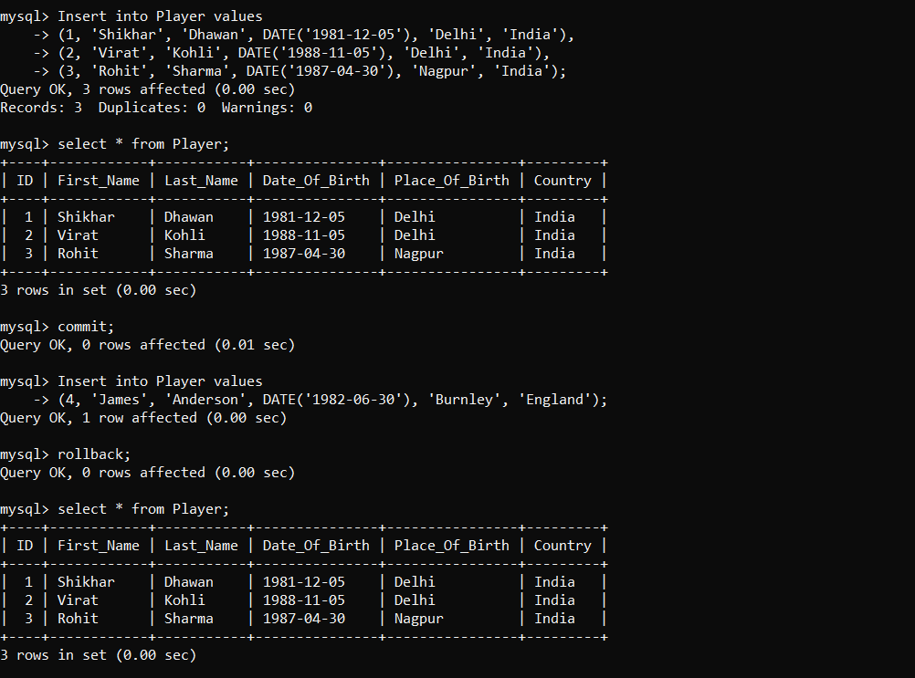
Figure 3.2 Rollback
 | Experiment Title: PL/SQL Architecture, Assignments and Expressions, Writing PL/SQL Code, Referencing Non-SQL parameters.
 | Laboratory: DBMS LAB
Experiment No: 6 | Department: | Semester:

What do you mean by PL/SQL?
In Oracle, PL/SQL (Procedural Language/SQL) is the procedural language extension to the non-procedural SQL. It combines the data manipulation power of SQL and the procedural power of standard programming languages. PL/SQL was developed by Oracle Corporation within the early ’90s to reinforce the capabilities of SQL. It integrates well with SQL* PLUS and other application development products of Oracle. PL/SQL is the superset of SQL. It provides SQL data manipulation commands and SQL data types. In PL/SQL, a block without any name is called Anonymous Block. PL/ SQL block consists of various functions, library, procedures, trigger, packages etc.

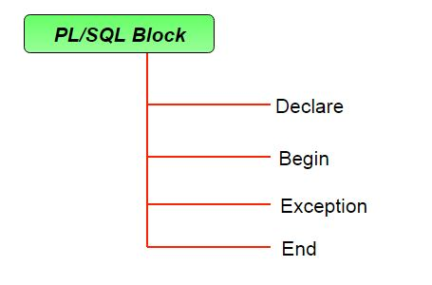
Figure 6.1 PL/SQL structure
PL/SQL Architecture:

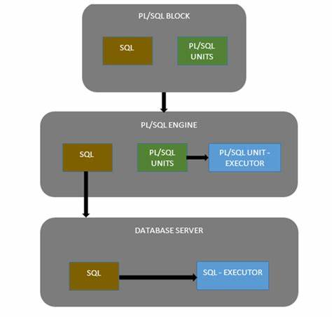
Figure 6.2 PL/SQL Architecture
Assignments and Expressions
In PL/SQL, you can assign values to variables using the := operator. Expressions can include variables, constants, literals, and function calls. For example:

DECLARE
v_salary NUMBER(7,2);
BEGIN
v_salary := 50000 * 1.10; -- Assigning a value using an expression
END;
/

Writing PL/SQL Code
When writing PL/SQL code, follow these steps:
- Declare: Define variables, constants, and types.
- Begin: Start the executable section where you write the logic.
- Exception: Handle exceptions or errors.
- End: End the block.

#Write a PL/SQL code for add two numbers and display the result?

DECLARE
num1 NUMBER := 10; -- First number
num2 NUMBER := 20; -- Second number
sum NUMBER; -- Variable to store the sum
BEGIN
sum := num1 + num2; -- Adding the two numbers
DBMS_OUTPUT.PUT_LINE('The sum of ' || num1 || ' and ' || num2 || ' is: ' || sum);
END;
/

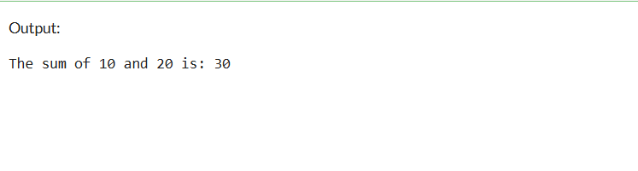
Figure 6.3 Sum of numbers

#Write a PL/SQL code for finding sum of 10 natural by using loops.

DECLARE
num NUMBER := 10; -- Number of natural numbers to sum
sum NUMBER := 0; -- Variable to store the sum
i NUMBER; -- Loop counter
BEGIN
FOR i IN 1..num LOOP
sum := sum + i; -- Adding each number to the sum
END LOOP;
DBMS_OUTPUT.PUT_LINE('The sum of the first ' || num || ' natural numbers is: ' || sum);
END;
/

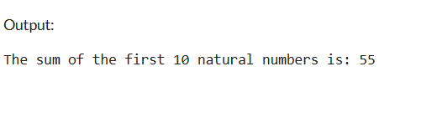
Figure 6.4 Sum of ten natural numbers
# Write a PL/SQL code to increase the salary of all doctors by 1000.

BEGIN
EXECUTE IMMEDIATE 'CREATE TABLE employees (
employee_id NUMBER PRIMARY KEY,
first_name VARCHAR2(50),
last_name VARCHAR2(50),
job_title VARCHAR2(50),
salary NUMBER(10, 2)
)';
END;
/
DECLARE
v_employee_id employees.employee_id%TYPE;
v_first_name employees.first_name%TYPE;
v_last_name employees.last_name%TYPE;
v_job_title employees.job_title%TYPE;
v_salary employees.salary%TYPE;
BEGIN
-- Insert values
INSERT INTO employees (employee_id, first_name, last_name, job_title, salary)
VALUES (101, 'John', 'Doe', 'Doctor', 50000);
INSERT INTO employees (employee_id, first_name, last_name, job_title, salary)
VALUES (102, 'Jane', 'Smith', 'Doctor', 40000);
INSERT INTO employees (employee_id, first_name, last_name, job_title, salary)
VALUES (103, 'Emily', 'Jones', 'Surgeon', 70000);
INSERT INTO employees (employee_id, first_name, last_name, job_title, salary)
VALUES (104, 'Michael', 'Brown', 'Doctor', 55000);

COMMIT;

-- Update salaries
UPDATE employees
SET salary = salary + 1000
WHERE job_title = 'Doctor';

COMMIT;

-- Display updated salaries
FOR doctor IN (SELECT employee_id, first_name, last_name, salary FROM employees WHERE job_title = 'Doctor') LOOP
DBMS_OUTPUT.PUT_LINE('ID: ' || doctor.employee_id ||
', Name: ' || doctor.first_name || ' ' || doctor.last_name ||
', Updated Salary: ' || doctor.salary);
END LOOP;
END;
/
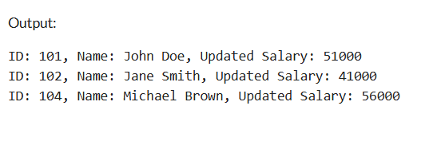
Figure 6.5 Update statement
Referencing Non-SQL Parameters
In PL/SQL, you can reference non-SQL parameters (like host variables) using the :variable_name syntax. These are typically used in embedded SQL or with tools like SQL*Plus.

Here’s an example using SQL*Plus:

Declare the host variable in SQL*Plus:
VARIABLE host_var NUMBER

Assign a value to the host variable:
EXEC :host_var := 100;

Reference the host variable in a PL/SQL block
BEGIN
DBMS_OUTPUT.PUT_LINE('The value of host_var is: ' || :host_var);
END;

Variable g_monthly_salary number
Define p_manual_salary=60000
Declare
y_salary number(9,2)=&p_annual_salary
Begin
g_monthly_salary=y_salary/12;
End;

Print g_monthly_salary

 | Experiment Title: Stored Procedures and Exception Handling.
 | Laboratory: DBMS LAB
Experiment No: 7 | Department: | Semester:

Stored Procedures
The PL/SQL stored procedure or simply a procedure is a PL/SQL block which performs one or more specific tasks. It is just like procedures in other programming languages.

Syntax
CREATE [OR REPLACE] PROCEDURE procedure_name
[(parameter_name [IN | OUT | IN OUT] type [, ...])]
{IS | AS}
BEGIN
< procedure_body >
END procedure_name;
CREATE [OR REPLACE] PROCEDURE procedure_name
[(parameter_name [IN | OUT | IN OUT] type [, ...])]
{IS | AS}
BEGIN
< procedure_body >
END procedure_name;

Example

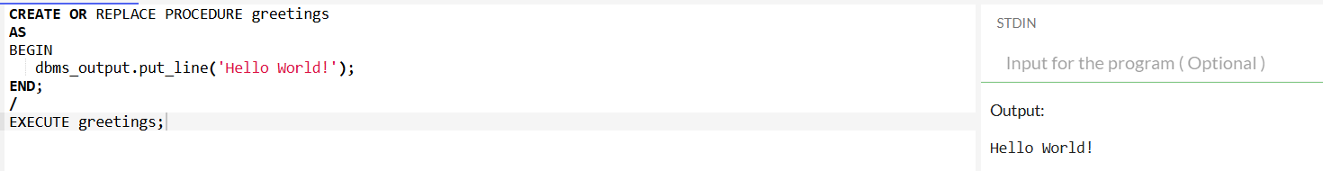
Figure 7.1 Stored procedure

Exception Handling
An exception is an error which disrupts the normal flow of program instructions. PL/SQL provides us the exception block which raises the exception thus helping the programmer to find out the fault and resolve it.

Syntax

WHEN exception THEN
statement;

DECLARE
declarations section;
BEGIN
executable command(s);
EXCEPTION
WHEN exception1 THEN
statement1;
WHEN exception2 THEN
statement2;
[WHEN others THEN]
/* default exception handling code */
END;

Example
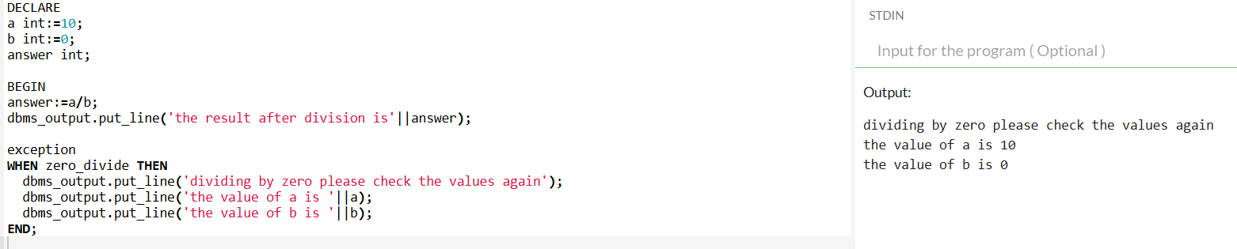
Figure 7.2 Exception

 | Experiment Title: Triggers and Cursor Management in PL/SQL.
 | Laboratory: DBMS LAB
Experiment No: 8 | Department: | Semester:

PL/SQL Triggers
PL/SQL triggers are block structures and predefined programs invoked automatically when some event occurs. They are stored in the database and invoked repeatedly in a particular scenario. There are two states of the triggers, they are enabled and disabled. When the trigger is created it is enabled. CREATE TRIGGER statement creates a trigger. A triggering event is specified on a table, a view, a schema, or a database. BEFORE and AFTER are the trigger Timing points. DML triggers are created on a table or view, and triggers. Cross edition triggers are created on Edition-based redefinition. System Triggers are created on schema or database using DDL or database operation statements. It is applied on new data only, it don't affect existing data.

Why are Triggers important?
The importance of Triggers are :
Automated Action: It helps to automate actions in response to events on table or views.
Data integrity: Constraint can be applied to the data with the help of trigger. It is used to ensure referential integrity.
Consistency: It helps to maintain the consistency of the database by performing immediate responses to specific events.
Error handling: It helps in error handling by responding to the errors. For example, If specific condition is not met it will provide an error message.

Trigger Syntax:
CREATE OR REPLACE TRIGGER trigger_name
BEFORE or AFTER or INSTEAD OF //trigger timings
INSERT or UPDATE or DELETE // Operation to be performed
of column_name
on Table_name
FOR EACH ROW
DECLARE
Declaration section
BEGIN
Execution section
EXCEPTION
Exception section
END;
/

CONSIDER THE TABLE CUSTOMERS:-

ID | NAME | AGE | ADDRESS | SALARY
1 | Ramesh | 32 | Ahmedabad | 2000.00
2 | Khilan | 25 | Delhi | 1500.00
3 | Kaushik | 23 | Kota | 2000.00
4 | Chaitalli | 25 | Mumbai | 6500.00
5 | Hardik | 27 | Bhopal | 8500.00
6 | Komal | 22 | MP | 4500.00
FOR EXAMPLE:-
CREATE OR REPLACE TRIGGER display_salary_changes BEFORE DELETE OR INSERT OR UPDATE ON customers FOR EACH ROW
WHEN (NEW.ID > 0) DECLARE
sal_diff number; BEGIN
sal_diff := :NEW.salary - :OLD.salary; dbms_output.put_line('Old salary: ' || :OLD.salary); dbms_output.put_line('New salary: ' || :NEW.salary); dbms_output.put_line('Salary difference: ' || sal_diff);

OUTPUT:
Trigger created.
INSERT INTO CUSTOMERS (ID, NAME, AGE,A DDRESS, SALARY) VALUES (7, 'Kriti', 22, 'HP', 7500.00 );

RESULT:
Old salary:
New salary: 7500 Salary difference:

UPDATE customers
SET salary = salary + 500
WHERE id = 2;

Old salary: 1500
New salary: 2000
Salary difference: 500

PL/SQL Cursor
When an SQL statement is processed, Oracle creates a memory area known as context area. A cursor is a pointer to this context area. It contains all information needed for processing the statement. In PL/SQL, the context area is controlled by Cursor. A cursor contains information on a select statement and the rows of data accessed by it.
A cursor is used to referred to a program to fetch and process the rows returned by the SQL statement, one at a time. There are two types of cursors:
- Implicit Cursors
- Explicit Cursors

Explicit cursors
Explicit cursors are defined by the programmers to have more control area on the context area. It has to be defined in the declaration section of the PL/SQL Block. Usually, It is defined on a SELECT Statement and it returns more than one row as output. We can iterate over the rows of data and perform the required operations.
Steps involved in creating explicit cursors:
Cursor Declaration for initializing the memory
CURSOR <cursorName> IS
SELECT <Required fields> FROM <tableName>;
Cursor Opening to allocate the memory
OPEN <cursorName>;
Cursor Fetching to retrieve the data
FETCH <cursorName> INTO <Respective columns>
Cursor Closing to release the allocated memory
CLOSE <cursorName>;

PL/SQL Explicit Cursor Example
Consider a table
ID | NAME | AGE | ADDRESS | SALARY
1 | Ramesh | 23 | Allahabad | 20000
2 | Suresh | 22 | Kanpur | 22000
3 | Mahesh | 24 | Ghaziabad | 24000
4 | Chandan | 25 | Noida | 26000
5 | Alex | 21 | Paris | 28000
6 | Sunita | 20 | Delhi | 30000

DECLARE
c_id customers.id%type;
c_name customers.name%type;
c_addr customers.address%type;
CURSOR c_customers is
SELECT id, name, address FROM customers;
BEGIN
OPEN c_customers;
LOOP
FETCH c_customers into c_id, c_name, c_addr;
EXIT WHEN c_customers%notfound;
dbms_output.put_line(c_id || ' ' || c_name || ' ' || c_addr);
END LOOP;
CLOSE c_customers;
END;
/

Output:
1 Ramesh Allahabad
2 Suresh Kanpur
3 Mahesh Ghaziabad
4 Chandan Noida
5 Alex Paris
6 Sunita Delhi
PL/SQL procedure successfully completed.

Implicit Cursors
Implicit cursors are automatically created by Oracle whenever an SQL statement is executed, when there is no explicit cursor for the statement. Programmers cannot control the implicit cursors and the information in it.
Whenever a DML statement (INSERT, UPDATE and DELETE) is issued, an implicit cursor is associated with this statement. For INSERT operations, the cursor holds the data that needs to be inserted. For UPDATE and DELETE operations, the cursor identifies the rows that would be affected.

Attributes of Implicit Cursors:
S.No | Attribute & Description
1 | %FOUND  Returns TRUE if an INSERT, UPDATE, or DELETE statement affected one or more rows or a SELECT INTO statement returned one or more rows. Otherwise, it returns FALSE.
2 | %NOTFOUND  The logical opposite of %FOUND. It returns TRUE if an INSERT, UPDATE, or DELETE statement affected no rows, or a SELECT INTO statement returned no rows. Otherwise, it returns FALSE.
3 | %ISOPEN  Always returns FALSE for implicit cursors, because Oracle closes the SQL cursor automatically after executing its associated SQL statement.
4 | %ROWCOUNT  Returns the number of rows affected by an INSERT, UPDATE, or DELETE statement, or returned by a SELECT INTO statement.

PL/SQL Implicit Cursor Example
Consider a table
ID | NAME | AGE | ADDRESS | SALARY
1 | Ramesh | 23 | Allahabad | 20000
2 | Suresh | 22 | Kanpur | 22000
3 | Mahesh | 24 | Ghaziabad | 24000
4 | Chandan | 25 | Noida | 26000
5 | Alex | 21 | Paris | 28000
6 | Sunita | 20 | Delhi | 30000

DECLARE
total_rows number(2);
BEGIN
UPDATE customers
SET salary = salary + 5000;
IF sql%notfound THEN
dbms_output.put_line('no customers updated');
ELSIF sql%found THEN
total_rows := sql%rowcount;
dbms_output.put_line( total_rows || ' customers updated ');
END IF;
END;
/
Output:
6 customers updated
PL/SQL procedure successfully completed.
ID | NAME | AGE | ADDRESS | SALARY
1 | Ramesh | 23 | Allahabad | 25000
2 | Suresh | 22 | Kanpur | 27000
3 | Mahesh | 24 | Ghaziabad | 29000
4 | Chandan | 25 | Noida | 31000
5 | Alex | 21 | Paris | 33000
6 | Sunita | 20 | Delhi | 35000

